

E-Project

**Web Designing**

**Beauty Care**

|  |  |
| --- | --- |
| **Authors** | **Aptech - C1810L - Group 4** |
| 1. TAI PHAM NGUYEN HUU – Student1167819 (Leader) 2. HUNG PHAN MINH - Student1165204 |
| **Centre Name** | Aprotrain Aptech |
| **Date** | 02th ,October 2019 |
| **Semester** | 1 |
| **Instructor** | TRUNG NGUYEN TRAN |

**HCM City, 2th October 2019**

Table of Contents

**PREFACE** 4

CHAPTER I: OVERVIEW 5

***1.*** ***Introduce the topic:*** 5

***2.*** ***Sitemap:*** 5

***3.*** ***Purpose of website:*** 6

***4.*** ***Some main pages:*** 6

CHAPTER II: TENDER REQUIREMENTS 7

***1.*** ***Functional Requirement*** 7

CHAPTER III: E-PROJECT DESIGN 7

***1.*** ***DFD Design for eProject*** 7

➢ **Define DFD** 7

➢ **Main Components of DFD** 8

➢ **DFD Analysis: Design main functions of system** 8

***2.*** ***Database Structure Design for eProject*** 9

CHAPTER IV: INTERFACE SNAPSHOT 10

CHAPTER V: USER GUIDE 18

***1.*** ***Homepage*** 18

***2.*** ***Register New Account*** 22

***3.*** ***Login:*** 24

***4.*** ***Manage Profile:*** 25

***5.*** ***Change Password:*** 26

***6.*** ***Logout:*** 27

***7.*** ***View and Select Product:*** 28

***8.*** ***Manage Cart and Make Payment:*** 29

***9.*** ***View About Us:*** 31

***10.*** ***View Contact Us:*** 32

CHAPTER VI: ADMIN GUIDE 32

***1.*** ***Get to Administrator View*** 32

***2.*** ***Manage Staff (Administrators)*** 34

***3.*** ***Manage Product Brand*** 37

***4.*** ***Manage Product Category*** 41

***5.*** ***Manage Product*** 44

***6.*** ***Manage Customer*** 48

***7.*** ***Manage Order*** 51

***8.*** ***Manage Feedback*** 53

***9.*** ***Manage Payment Method*** 54

***10.*** ***Manage Homepage Content*** 56

***11.*** ***Manage Store Information*** 57

***12.*** ***Manage About Us Content*** 60

CHAPTER VII: DEVELOPER GUIDE 61

***1.*** ***Install Xampp*** 61

**a.** **Change Port:** 61

**b.** **Create Account for user xampp:** 63

**c.** **Create Database and Data** 65

**d.** **Access the website** 66

# **PREFACE**

Today, information technology has developed strongly following width and depth. Electronic computers are no longer a rare medium is becoming more and more a popular tool for children to work and play people, not only in the workplace but also in the family. Especially public Information technology is applied in all fields of economics, politics, society ... Applications Information technology and computerization are considered one of the decisive factors set in national, organizational and in-store operations. It plays the role The game is very important and can create a powerful breakthrough.

The INTERNET network is one of the most valuable and great products become an indispensable tool, the foundation for transmission and exchange global information. By INTERNET, we have done the merits The faster speed, much lower cost than the traditional way. This, in turn, promotes the birth and development of e-commerce around the world, significantly altering the cultural face, improving people's lives. In production and business activities, the typical trade has been confirmed to be exposed advancing and promoting the development of enterprises. For an online shop, advertising promote and introduce products to customers to meet increasing shopping needs Customer's will be necessary. Therefore, our group has carried out the topic "Building Website development for selling beauty care”. Shop will be the place where customers can choose for themselves the favorite products and in accordance with the current fashion trend.

The website is called SYMBLON BEAUTY and will be the place where the store best promotes all the products they sell. Through this we would like to express our sincere thanks and express gratitude to you dedicated instruction of teachers in the school "Aptech international programmer training system". Especially Mr. TRUNG NGUYEN TRAN, who directly instructed, taught and helped us during the implementation of this project.

# CHAPTER I: OVERVIEW

1. ***Introduce the topic:***

Business - buying is an indispensable need for each of us. In the current competitive era, the introduction of business products to individuals with low cost and high efficiency is a dilemma of business people with the demand for shopping with multi-products, Quality and affordability of consumers. So, our team conducted the website design to buy and sell goods online to help the stores grow faster, helping the store owners to manage their stores in a better way.

1. ***Sitemap:***

The website includes two parts: Customer Site and Administrator Site

* **Sitemap for Customer Site**

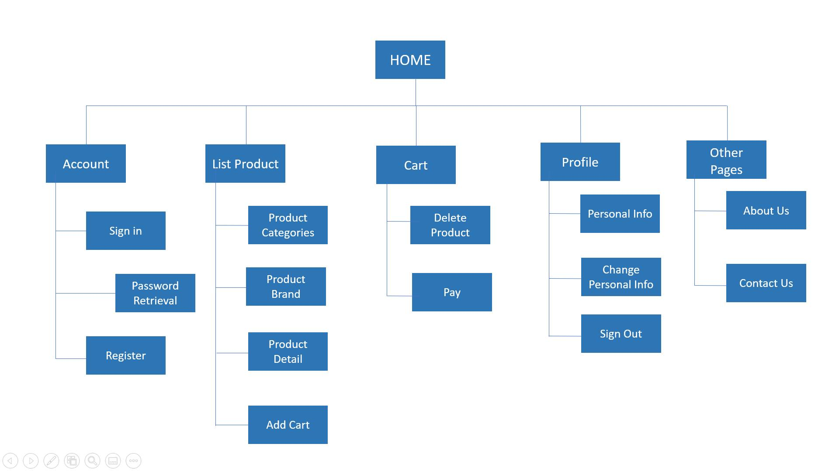

* **Sitemap for Admin Site**

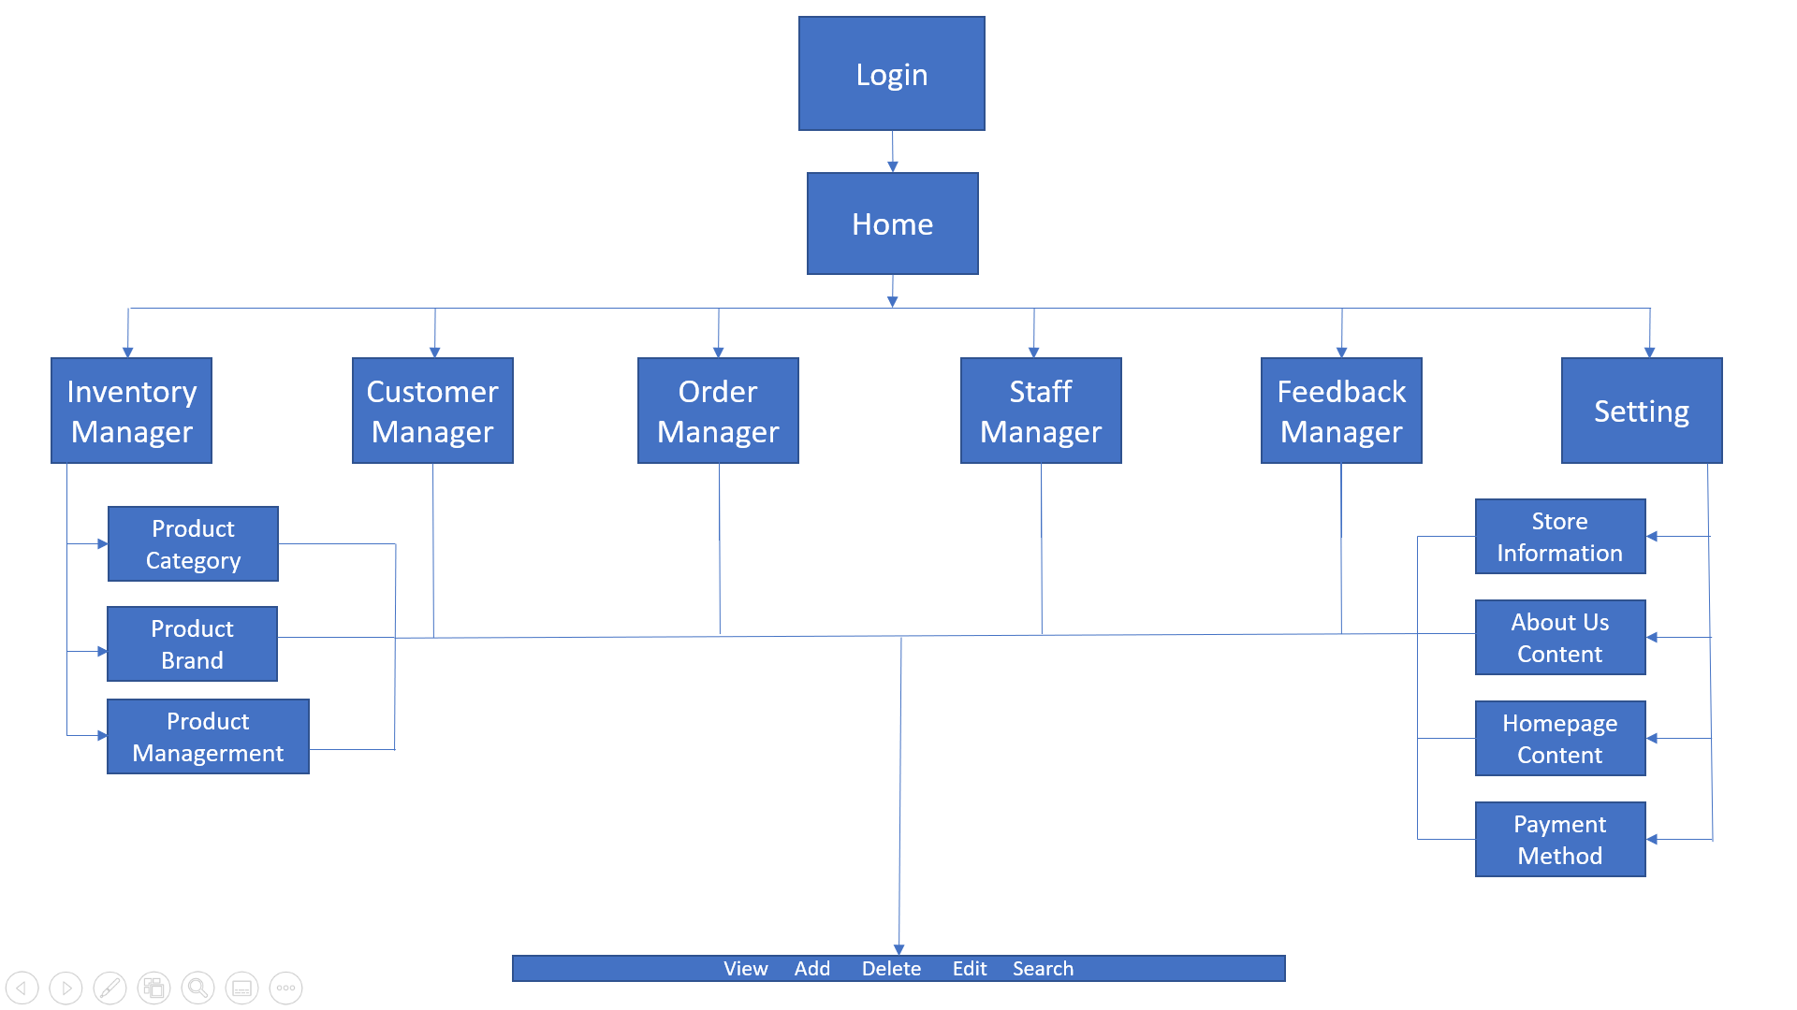

## ***Purpose of website:***

The goal of the website is to introduce and promote the store. Provide products

The beauty care that young people like now. Customers know detailed information about products such as product name, price, photo ...

In addition, the website aims to introduce more known customers shopping, closing the gap and solving long-distance problems difficult travel or traffic congestion ... Make the business of the door goods are more developed.

## ***Some main pages:***

* **Home page**: This is an introduction page of the shop's best selling products. In addition, you can learn more about collections, hot shop promotions, links to page like products, about us, contact us, login, register, ,..
* **Products**: This is the products page to view and add products to cart if the customer want to buy.
* **About us**: This page introduces customers with more information of stores.
* **Contact us page**: This page displays the location of shop for customer come to buy. This page contains shop information (such as: location, website, phone, …) for customers to contact.

CHAPTER II: TENDER REQUIREMENTS

1. ***Functional Requirement***

* The Home Page should be created with proper sections, graphics and with a suitable logo.
* The look and feel of the project must be made user friendly and uniformity in the color combination must be maintained.
* About us, Contact Us (address and map) must be added. In the Contact Us page the website of all the shops location must be given.
* All the categories of the products like HAIR, SKIN, MAKE-UP KITS, NAIL PAINTS, NAIL ARTS, JEWELLRY, WEDDING KITS, UPCOMING PRODUCTS & so on. For each product the cost must be mentioned in the list.
* Feedback page must be added to take the valuable feedback from the users.
* Contact Us, About Us.
* Use GeoLocation API to show the address or location of SIMPLON’s Beauty care centre on the maps.
* Gallery section can be included.
* Navigation of the project must be made user friendly.
* Customer must be allowed to place the order by selecting the product.
* While placing the dummy order, the total cost of the order must be calculated.

1. ***Non-Functional Requirement***

* A minimum computer system that will help you access all the tools in the courses is a Pentium 166 or better.
* 64 Megabytes of RAM or better.

# CHAPTER III: E-PROJECT DESIGN

1. ***DFD Design for eProject***

* **Define DFD**
* Data Flows Diagram (DFD) describes the information flow in the system. The next step of system analysis is to consider in detail the information necessary for the implementation for functions discussed above and the one necessary for the improvement of the functions. Modeling tool frequently used for this purpose is DFD. DFD will support 4 main activities.
  + **Analysis:** DFD is used to determine requirement of users. From DFD, all system stakeholders can share the same view on how the data will flow within the system and between the functions.
  + **Designing:** DFD is used to map out plan and illustrate solution to system analysts and other stakeholders while designing a new system.
  + **Communication:** DFD provides simplicity and ease-to-understand to system analysts as well as other stakeholders.
  + **Document**: DFD is used to provide special description of requirement and system design. DFD provide an overview of key functional components of the system, along with other tools like database dictionary, process specification, relevant stakeholders will get the idea of which information will be exchanged and how.
* **Main Components of DFD**

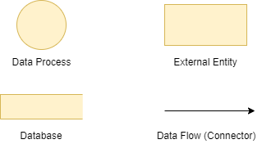

* 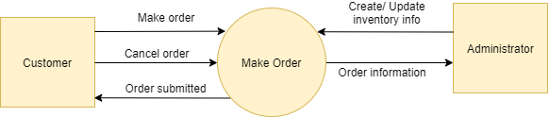**DFD Analysis: Design main functions of system**

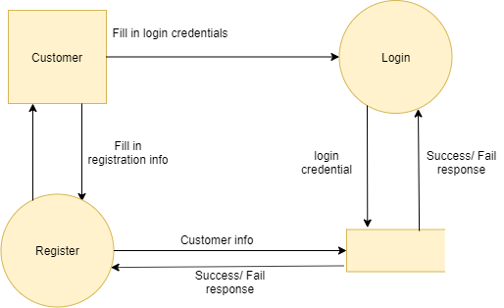Level 0: Making Order

Level 1: Login and Register Account

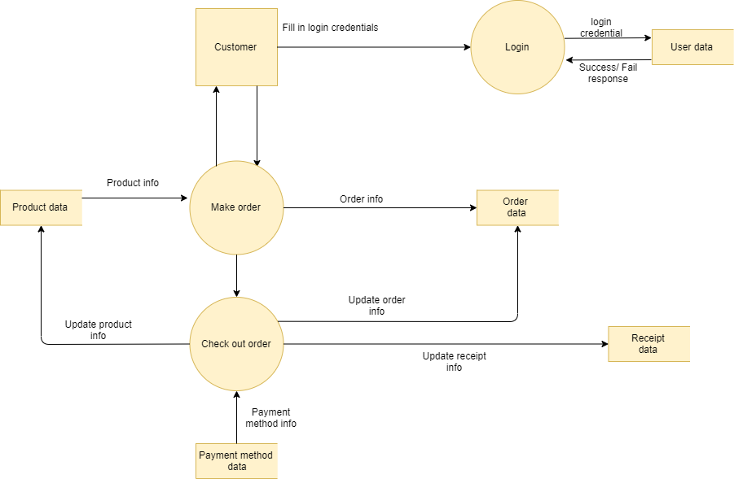

Level 2: Making Order and Payment

1. ***Database Structure Design for eProject***

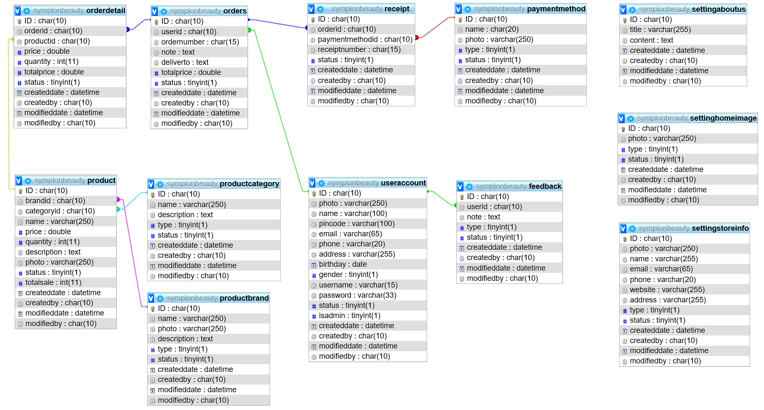

CHAPTER IV: INTERFACE SNAPSHOT

* 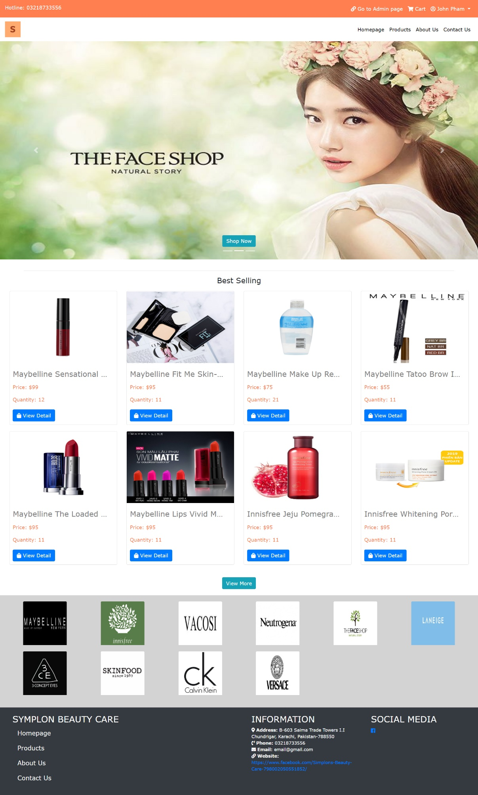**Home Page:**

Figure : Homepage

* **Register:**

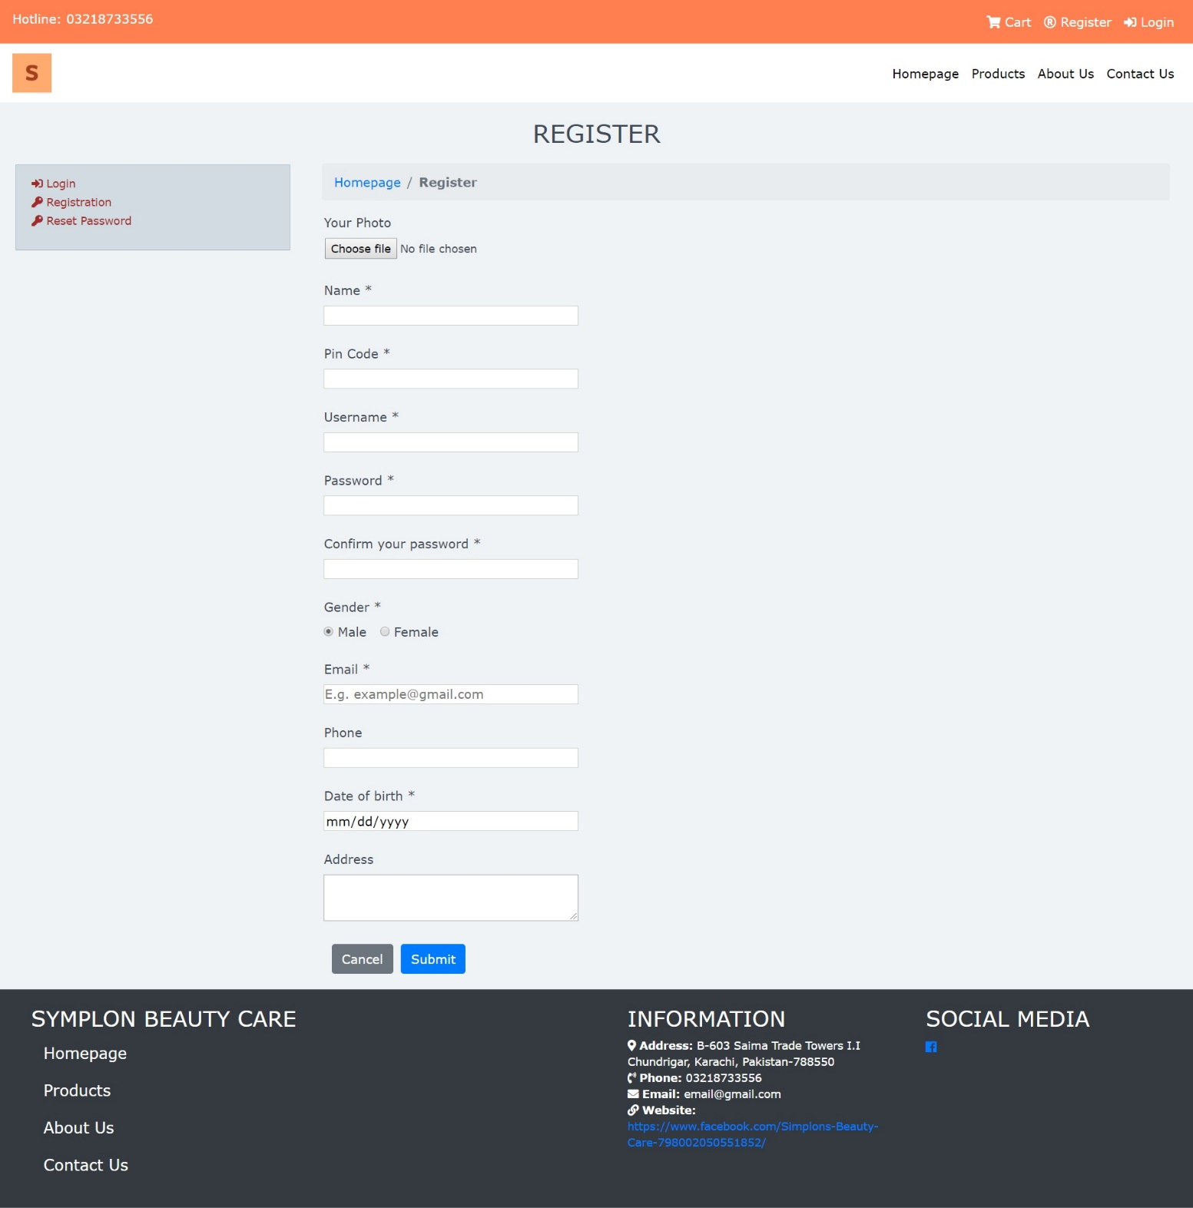

* **Login**

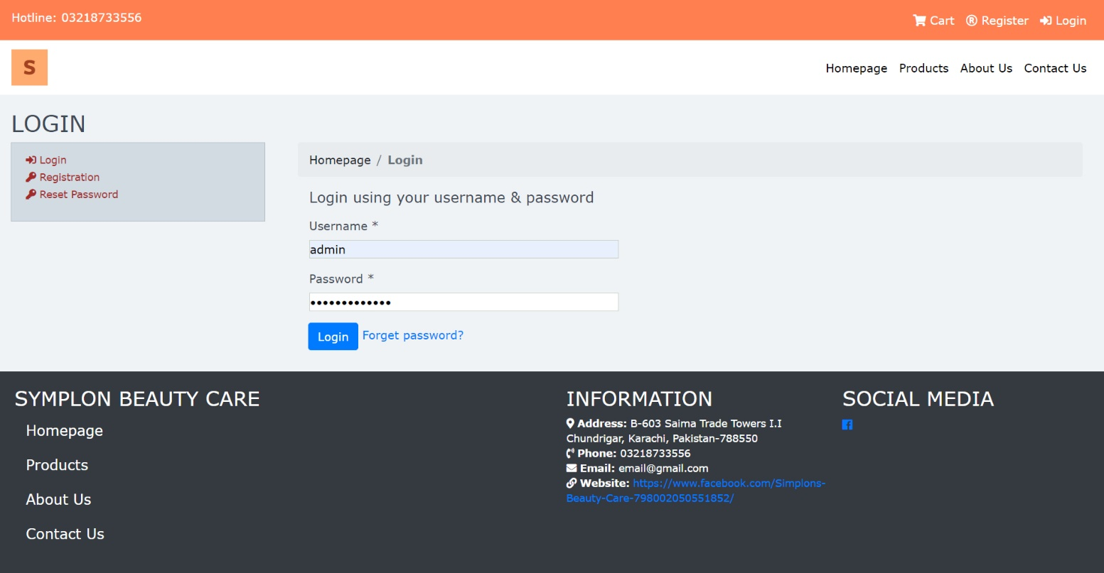

* **Product List:**

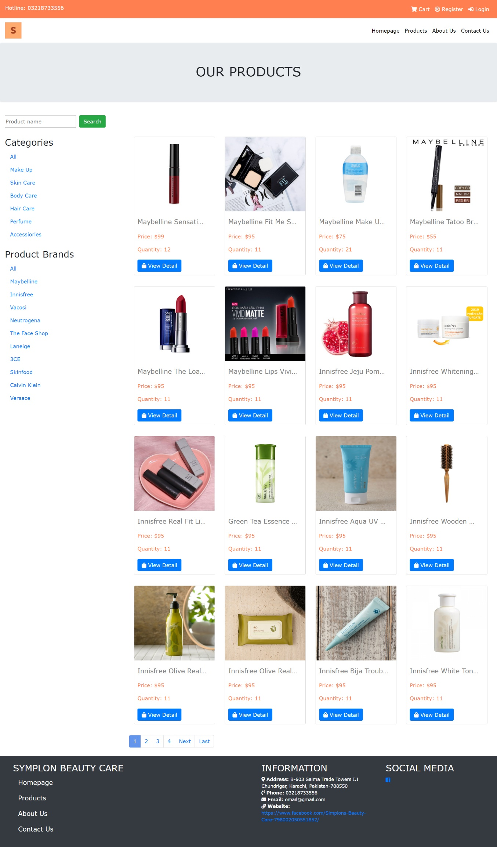

* **Product Detail:**

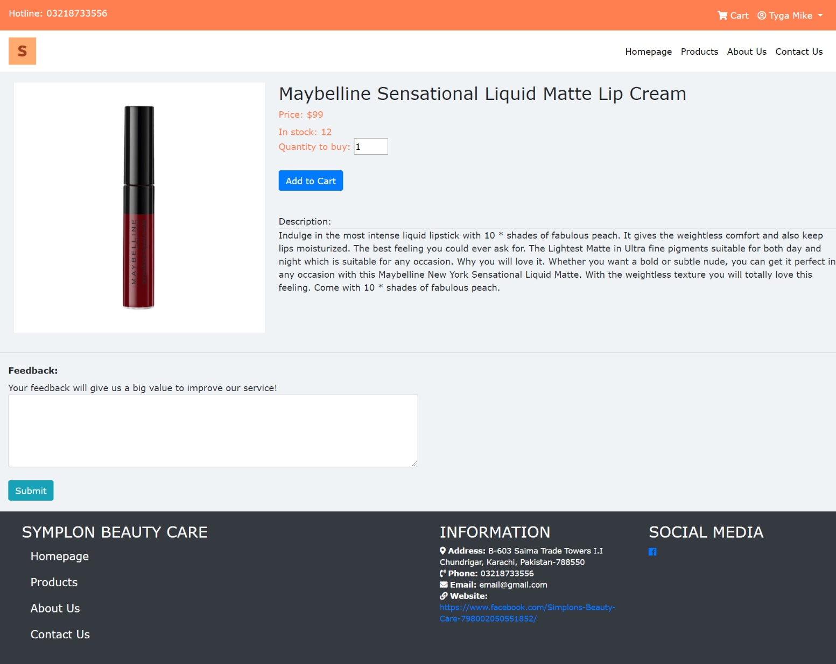

* **Profile:**

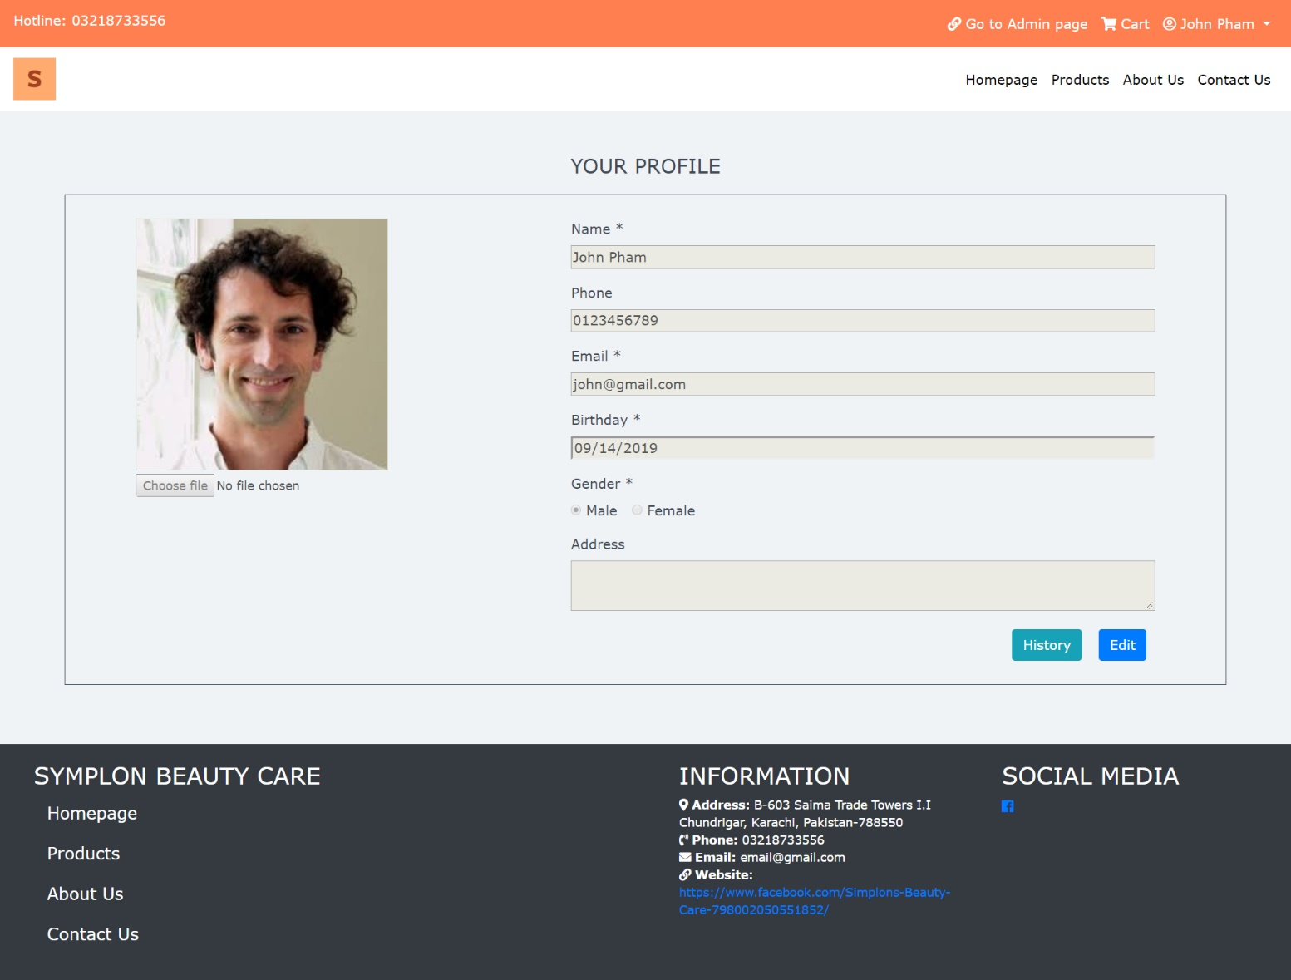

* **Profile History**

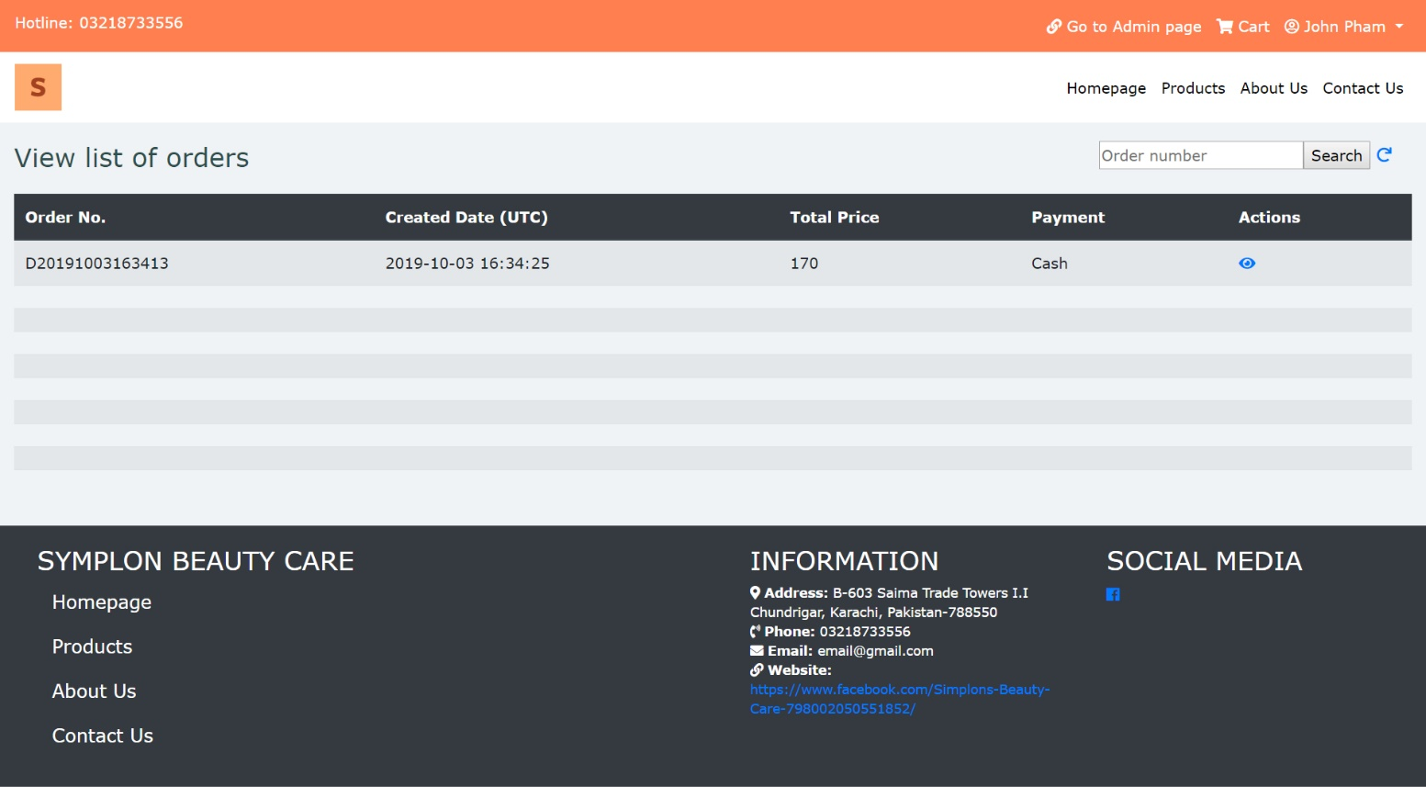

* **Profile History Detail**

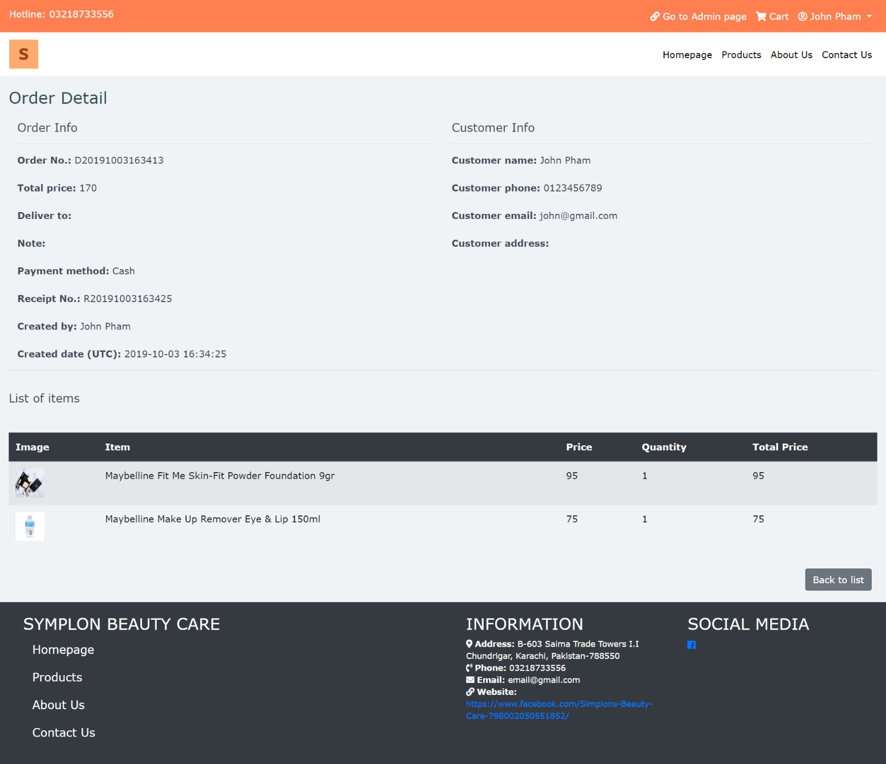

* **Cart Page:**

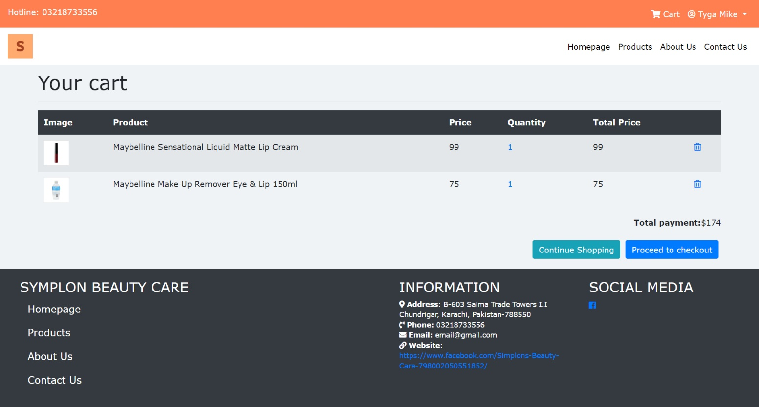

* **Payment Page**

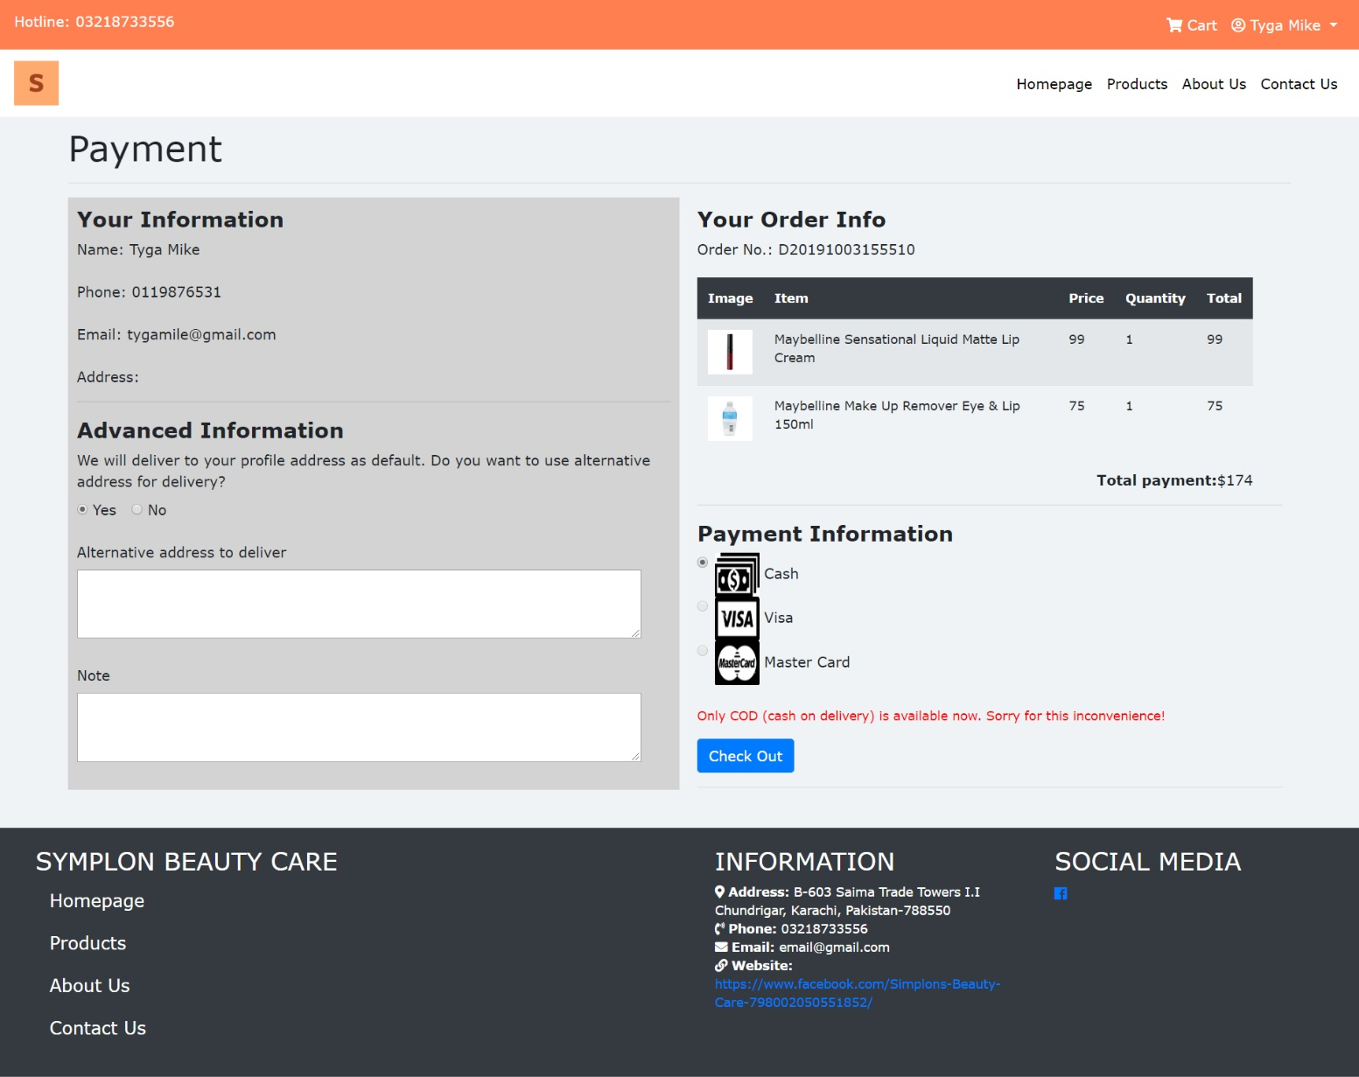

CHAPTER V: USER GUIDE

1. ***Homepage***
   * + - 1. **Description:**

* The Homepage of the website will be the default page that end users will see when they get to use the website. The Homepage includes the following information/sections:
  + Gallery of main images that system administrators set up to display on the interface to attract customers.
  + The collection of best-selling products.
  + The list of popular product brands.
  1. **Design and Operation:**
* **The Homepage:**

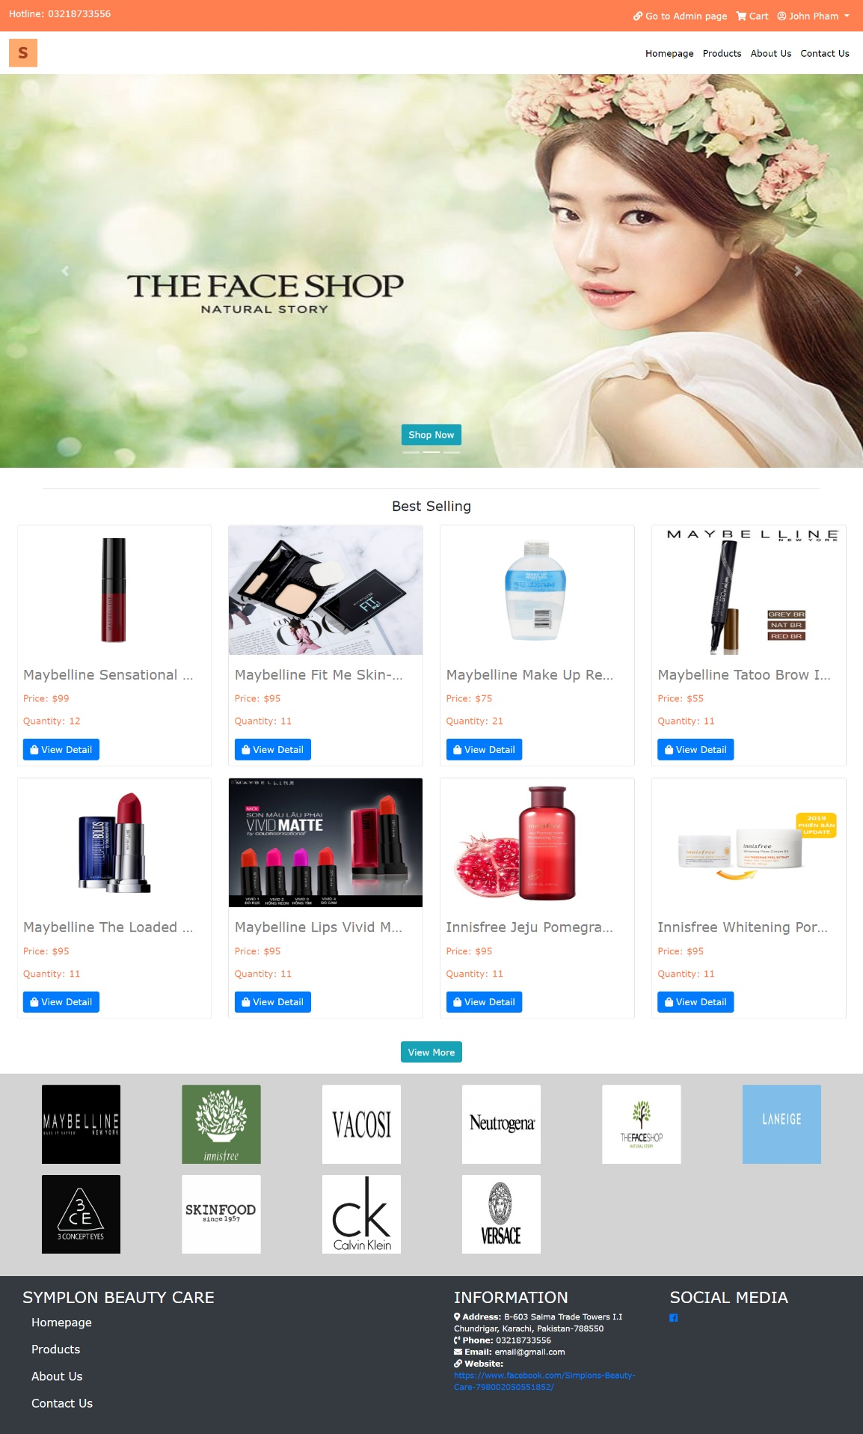

* **How to get to other functions:**
* **View list of products:** Customers can go to this function to have an overview of all products of Symplon’s Beauty Care Center which are currently available to sell. *(Refer to “Chapter V 🡪 1. Homepage 🡪 7. View and Select Product” for further information)*

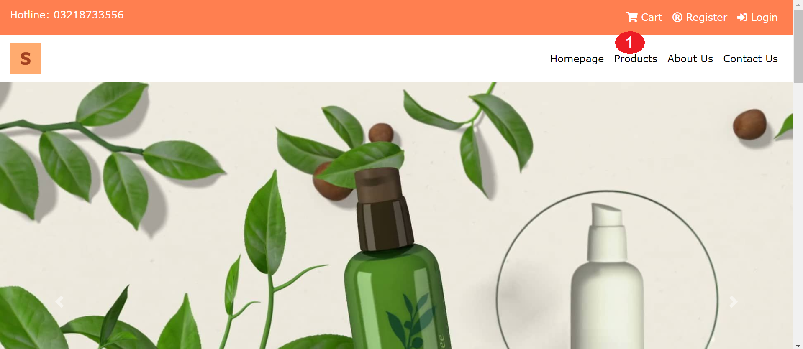

|  |  |
| --- | --- |
| **Operation No.** | **Description** |
| 1 | Click on this item on the header menu will direct customers to the page displaying all products which are currently on sale |
| 2 | Click on this button will direct customers to the page displaying all products which are currently on sale |

* **View “About Us”:** Customers can read some stories written by Symplon’s Beauty Care Center. *(Refer to “Chapter V 🡪 1. Homepage 🡪 10. View About Us” for further information)*

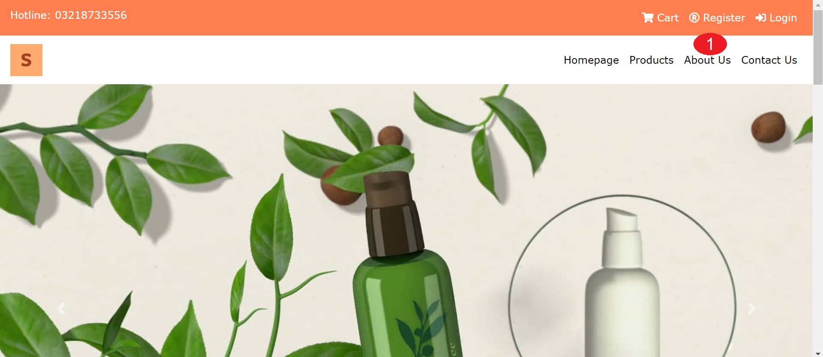

|  |  |
| --- | --- |
| **Operation No.** | **Description** |
| 1 | Click on this item on the header menu will direct customers to the page displaying About Us’s content |

* **View “Contact Us”:** Customers can view the contact information of Symplon’s Beauty Care Center so that they can contact the center in case of any support needed. *(Refer to “Chapter V 🡪 1. Homepage 🡪 11. View Contact Us” for further information)*

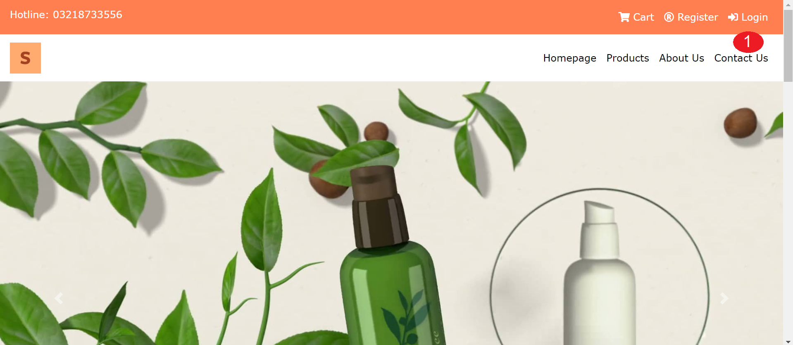

|  |  |
| --- | --- |
| **Operation No.** | **Description** |
| 1 | Click on this item on the header menu will direct customers to the page displaying Contact Us’s content |

* **View cart’s detail:** Customers can view their cart as well as the list of products which have been selected to buy. *(Refer to “Chapter V 🡪 1. Homepage 🡪 8. View Contact Us” for further information)*

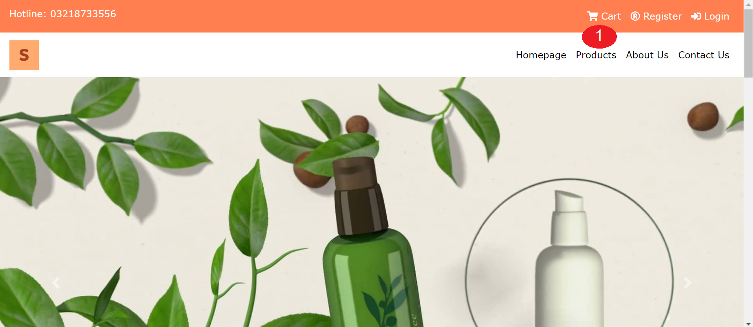

|  |  |
| --- | --- |
| **Operation No.** | **Description** |
| 1 | Click on this item on the header menu will direct customers to the page displaying Contact Us’s content |

* **Get back to homepage:** Customers can get back to the homepage from any other module.

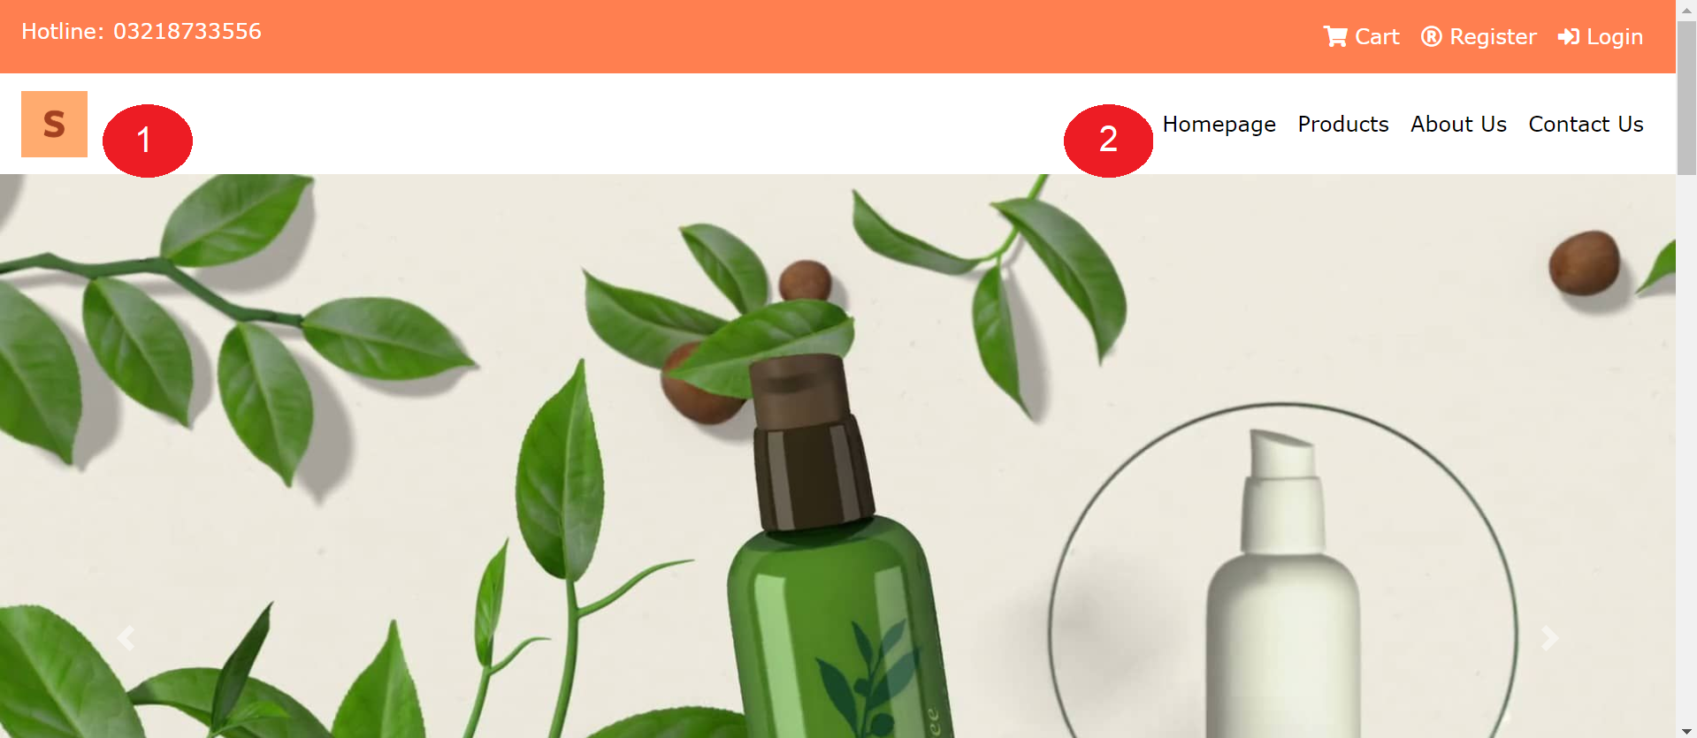

|  |  |
| --- | --- |
| **Operation No.** | **Description** |
| 1 | Click on this item on the header menu will direct customers to the Homepage |
| 2 | Click on the icon on the header menu will direct customers to the Homepage |

1. ***Register New Account***
   * + - 1. **Description:**

* Users can register for their new account so that they can do more action on the website which guest-users cannot do, such as:
  + Give feedbacks.
  + Add products to cart.
  + Make payment.
    - * 1. **Design and Operation:**
* **How to get to registration page:** When users haven’t yet signed in, then on the header menu of the website, there will be the “Registration” option for user to register a new account.

**<**image here**>**

**.**

|  |  |
| --- | --- |
| **Operation No.** | **Description** |
| 1 | Click on this item on the header menu will direct customers to the Registration page |

* **Register New Account:**

**<**image here**>**

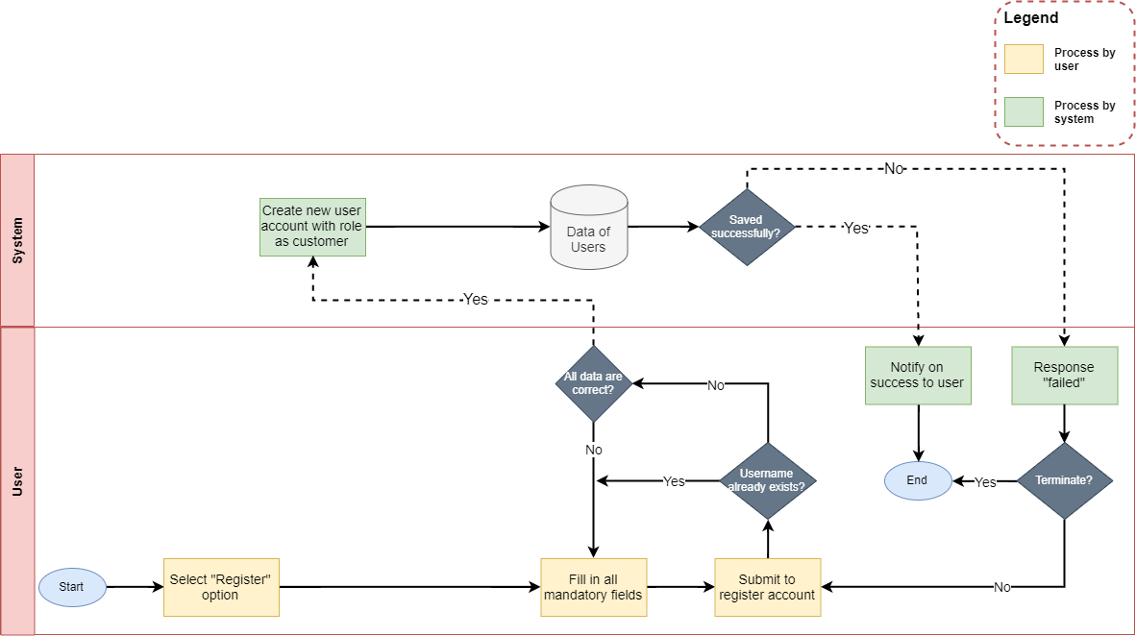

* + To finish registering new account, user needs to input all mandatory fields on the form:

|  |  |
| --- | --- |
| **Fields** | **Description** |
| Photo | * This field is not mandatory. * User can upload the photo to use as his/her avatar. * User can only upload image file with current supported extension as: .png .gif .jpge .jpg. * User can only upload image file whose size is not larger than 5MB. |
| Name | * This field is mandatory. * Name will be display throughout the website. |
| Pin Code | * This field is mandatory. * Pin Code will be used as security code to reset customer’s password. Therefore, it is only shown when user register a new account, there is no other place where this value will be shown. |
| Username | * This field is mandatory. * This field will be used as login credential along with customer’s password. * Username can only contain alphabet and digit character, cannot include space or special character. * Username must be unique in the system. |
| Password | * This field is mandatory. * This field will be used as login credential along with customer’s username. * Password can contain alphabet, digit character and special character, cannot include space. |
| Confirm Password | * This field is mandatory. * This field must be matched with the “Password” field. |
| Gender | * This field is mandatory. * Allow user to select his/ her gender |
| Email | * This field is mandatory. * Allow user to input his/ her email. Email format must be correct. |
| Phone | * This field is not mandatory. * Allow user to input his/ her phone |
| Date of birth | * This field is mandatory. * Allow user to select his/ her birthday |
| Address | * This field is not mandatory. * Allow user to input his/ her address |

* + When user submits to register new account and all the information are correct, user’s account will be created in the system with role as “customer” and the user will be directed to the login page.

1. ***Login:***
2. **Description:**

* Users can sign in into the website to have permission on all features within the customer’s site.

1. **Design and Operation:**

* **How to get to login page:** When users haven’t yet signed in, then on the header menu of the website, there will be the “Login” option for user to sign in into their account on the website.

**<**image here**>**

**.**

|  |  |
| --- | --- |
| **Operation No.** | **Description** |
| 1 | Click on this item on the header menu will direct customers to the Login page |
| 2 | Click on this option will direct user to the page for him/her to reset his/her password |
| 3 | Click on this option will direct user to the page for him/her to reset his/her password |

* **Login into website:**

**<**image here**>**

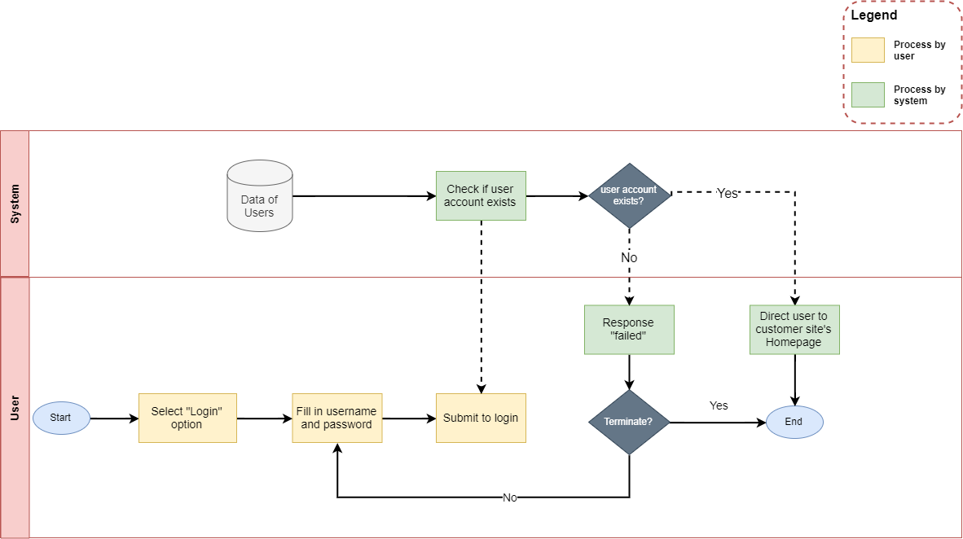

* + To login into the website, user needs to input the login credentials on the login form:

|  |  |
| --- | --- |
| **Fields** | **Description** |
| Username | * This field is mandatory. * This field will be checked if it exists as well as it is mapped with the inputted password or not. |
| Password | * This field is mandatory. * This field will be checked if it is mapped with the inputted username or not. |

* When user submits to login and all login credentials are correct, user will sign in into system successfully with his/ her user account and the user will be directed to the homepage.
* **Forget Password:**

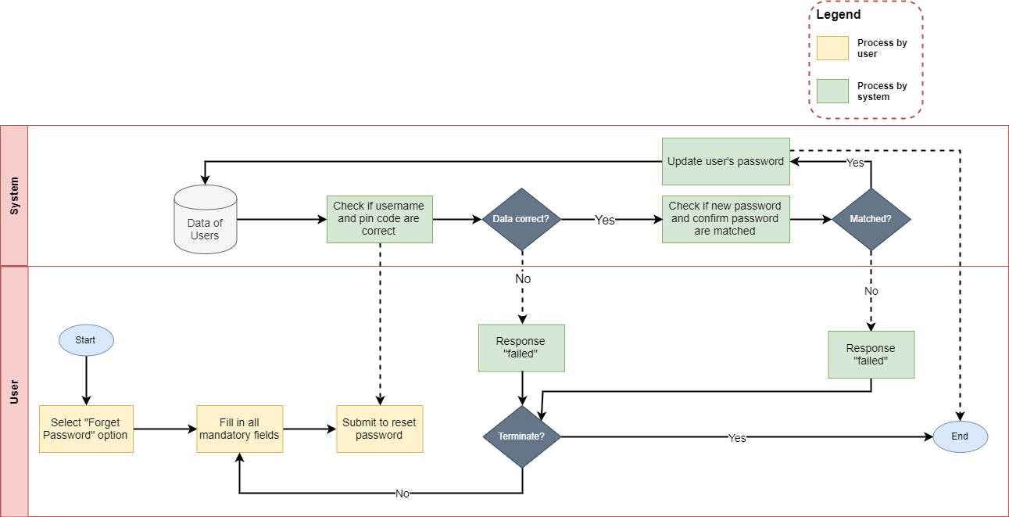

* + If user forgets his/her password, user can reset his/her password by input the relevant information as:

|  |  |
| --- | --- |
| **Fields** | **Description** |
| Username | * This field is mandatory. * This field will be checked if it exists as well as it is mapped with the inputted Pin Code or not. |
| Pin Code | * This field is mandatory. * This field will be checked if it exists as well as it is mapped with the inputted username or not. |
| New Password | * This field is mandatory. * This will be saved as the new password which user can use to login the account instead of the old one. * New Password can contain alphabet, digit character and special character, cannot include space. |
| Confirm New Password | * This field is mandatory. * This field must be matched with the “New Password” field. |

When user submits to reset his/her password and all login fields are inputted correctly, new password will be created for user and the user will be directed to the login. Now he/ she can use the new password to login.

1. ***Manage Profile:***
2. **Description:**

* Users can manage his/her profile information as well as his/ her history transaction (if any):

1. **Design and Operation:**

* **How to get to user profile page:** When users have already signed in, then on the header menu of the website, user’s name will be displayed. Clicking on the user’s name will show the list of options which contains “Profile” option for user to get to the Profile page to manage his/her profile information.

**<**image here**>**

|  |  |
| --- | --- |
| **Operation No.** | **Description** |
| 1 | Click on this option will direct customers to the Profile page |

* **How to get to History Transaction page:** When users have already signed in, then users can view their history transaction via Profile page. Users can also see detail of each order which they’ve made.

**<**image here**>**

|  |  |
| --- | --- |
| **Operation No.** | **Description** |
| 1 | Click on this option will direct customers to the History page |
| 2 | Click on this option will direct customers to page displaying detail of each history order |

1. ***Change Password:***
2. **Description:**

* Users can change their old password into a new one.

1. **Design and Operation:**

* **How to get to Change Password page:** When users have already signed in, then on the header menu of the website, user’s name will be displayed. Clicking on the user’s name will show the list of options which contains “Change Password” option for user to get to the page for resetting his/her password.

**<**image here**>**

|  |  |
| --- | --- |
| **Operation No.** | **Description** |
| 1 | Click on this option will direct customers to the Change Password page |

* **Change Password:**

**<**image here**>**

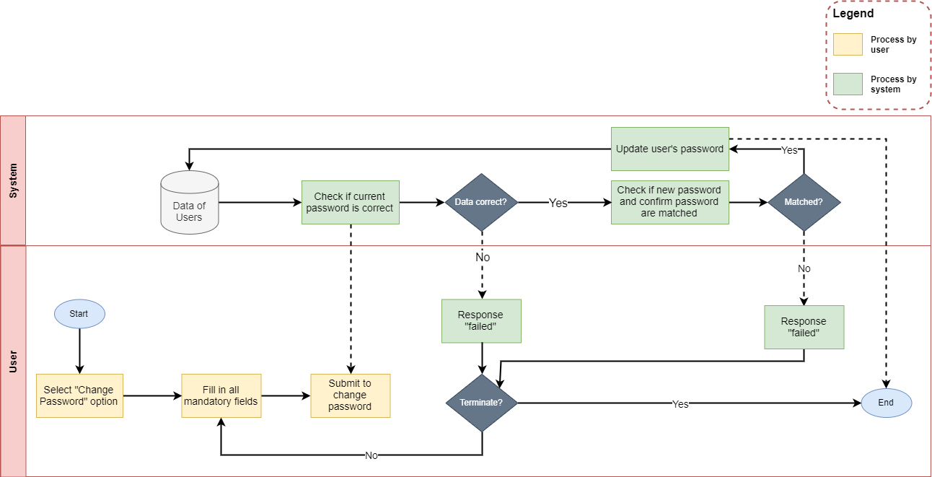

* + User can reset his/her password by input the relevant information as:

|  |  |
| --- | --- |
| **Fields** | **Description** |
| Current Password | * This field is mandatory. * This field will be checked if it is correct as user’s current password or not. |
| New Password | * This field is mandatory. * This will be saved as the new password which user can use to login the account instead of the old one. * New Password can contain alphabet, digit character and special character, cannot include space. |
| Confirm New Password | * This field is mandatory. * This field must be matched with the “New Password” field. |

* When user submits to reset his/her password and all login fields are inputted correctly, new password will be created for user. Now he/ she can use the new password to login.

1. ***Logout:***
2. **Description:**
   * Customer can log out of the website whenever he/she doesn’t want to use his/her account to perform any transaction anymore.
3. **Design and Operation:**

* **How to get log out:** When users have already signed in, then on the header menu of the website, user’s name will be displayed. Clicking on the user’s name will show the list of options which contains “Logout” option for user to log out his/ her account from the website.

**<**image here**>**

|  |  |
| --- | --- |
| **Operation No.** | **Description** |
| 1 | Click on this option will log out the customer’s account from the website and direct customers to the Homepage |

1. ***View and Select Product:***
2. **Description:**

* User can view the list of products which are currently on sale. On the list of product, customer can:
  + View the main information of each product as well as its current quantity.
  + Select to view the detail of each product.
  + Filter the list of products by product category and/or product brand.
  + Search the products by their names.
* The customer can also select a specific product to add it into the cart to make an order when he/she want to buy the product.

1. **Design and Operation:**

* **How to get to the list of products:** User can view the list of products whenever he/she has already logged in or not. On the header menu of the website, there will be the “Products” option for user to get to the page displaying the list of products which are currently on sale.

**<**image here**>**

|  |  |
| --- | --- |
| **Operation No.** | **Description** |
| 1 | Click on this option will log out direct the customer to the page displaying list of products |

* **How to get to the page displaying product’s detail:** On the list of products, user can click on the product information or click on the “View Detail” button to go to page displaying the product’s detailed information

**<**image here**>**

|  |  |
| --- | --- |
| **Operation No.** | **Description** |
| 1 | Click on this option will log out direct the customer to the page displaying detailed information of the product |

* **Select to add product to cart:** Customer can only add product to his/her cart after he/ she has already logged in.
* Whenever customer wants to buy the product, he/ she can go to the page displaying product’s detail. From there, customer can select the quantity he/ she wants to buy as well as submit to add the selected product with the selected quantity to customer’s cart.

**<**image here**>**

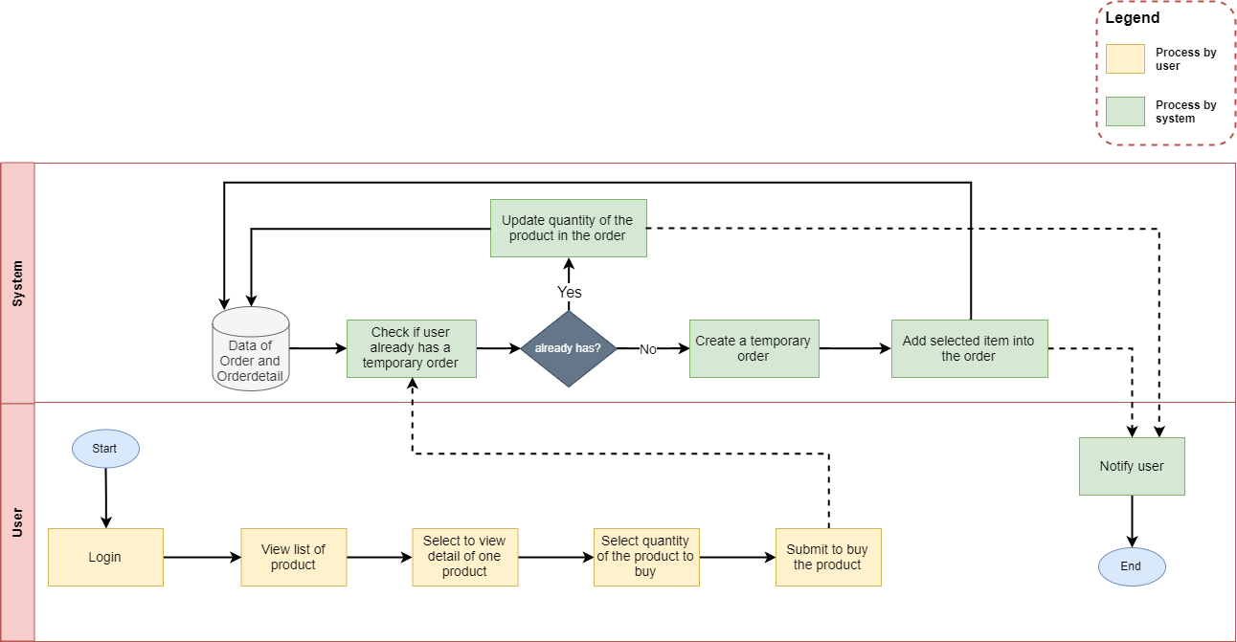

|  |  |
| --- | --- |
| **Fields** | **Description** |
| Quantity | * This field is mandatory. * This field will be checked if the selected quantity that customer want to add to his/ her cart is sufficient comparing to the product’s current stock or not. |

* When customer submits to add the product to cart with the appropriate selected quantity, the product will then be added to the customer’s cart. If the product has already been added to customer’s cart before. The previously added product will be kept in the cart but its quantity will be increased accordingly.

1. ***Manage Cart and Make Payment:***
2. **Description:**

* Cart is where customer can view the product(s) that he/she has selected to buy but doesn’t make payment yet. From there, customer can proceed to make payment for the order.

1. **Design and Operation:**

* **How to open Cart page:** Customer can only view and manage his/ her after he/ she has already logged in.

**<**image here**>**

|  |  |
| --- | --- |
| **Operation No.** | **Description** |
| 1 | Click on this option will direct customer to the Cart page. |

* **Change product’s quantity:** Customer can change the current quantity of the product in the cart by clicking on the quantity value. System will direct customer to the page displaying product detail so that he/ she can add more quantity to the product.

**<**image here**>**

|  |  |
| --- | --- |
| **Operation No.** | **Description** |
| 1 | Click on this option will direct customer to the page displaying list of product(s) in the customer’s cart. |

* **Remove product from the cart:** Customer can remove the selected product out of the cart by clicking on the “Delete” icon.

**<**image here**>**

|  |  |
| --- | --- |
| **Operation No.** | **Description** |
| 1 | Click on this icon will remove the product out of the customer’s cart. |

* **Continue shopping:** Customer can add more only add product(s) to his/ her cart by clicking on the “Continue Shopping” button.

**<**image here**>**

|  |  |
| --- | --- |
| **Operation No.** | **Description** |
| 1 | Click on this button will direct customer to the list of products page. |

* **Proceed to Payment:** Customer can make payment for his/ her order by clicking on “Proceed to checkout” button.

**<**image here**>**

|  |  |
| --- | --- |
| **Operation No.** | **Description** |
| 1 | Click on this button will direct customer to the page to make payment for the order. |

* **Make Payment:** Customer can make payment for his/ her order by selecting and filling in the relevant information. Then clicks on “Checkout” button.

**<**image here**>**

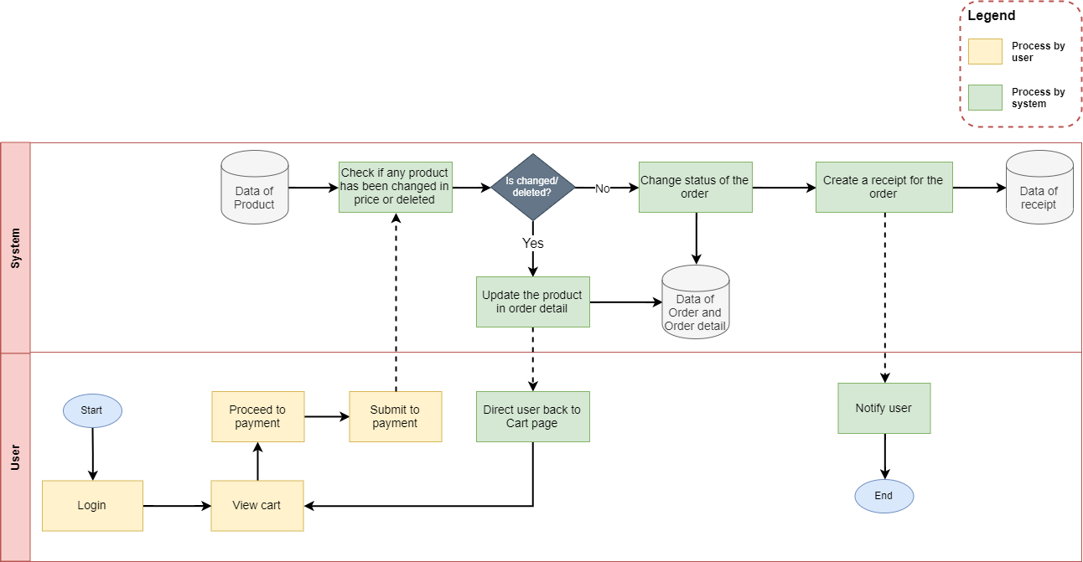

|  |  |
| --- | --- |
| **Fields** | **Description** |
| Alternative Address (to deliver) | * This field is not mandatory. * If customer selects to use alternative address, then after he/ she has made payment for the order, the address where the package will be delivered to is the inputted alternative address. Else, the address to deliver to will be default as customer’s profile address. |
| Note | * This field is not mandatory. * Customer can add some notes for the order in this field. |
| Payment method | * This field is mandatory. * If customer selects option as Cash (Cash on Delivery), then the system will generate a temporary receipt for customer which is not paid yet (not yet implement the workflow when customer selects other payment method) |

* When customer submits to checkout after filled in all relevant information, a receipt will be generated for the customer and the Symplon’s Beauty Care Center will also receive this order from the customer.

1. ***View About Us:***
2. **Description:**

* Customers can read some stories written by Symplon’s Beauty Care Center by going to this module.

1. **Design and Operation:**

* **The About Us Page:**
* **How to get to About Us page:** User can view the About Us page whenever he/she has already logged in or not. On the header menu of the website, there will be the “About Us” option, clicking on this will open About Us page.

<image here>

|  |  |
| --- | --- |
| **Operation No.** | **Description** |
| 1 | Click on this item on the header menu will direct customers to the page displaying About Us’s content |

1. ***View Contact Us:***
2. **Description:**

* Customers can view the contact information of Symplon’s Beauty Care Center so that they can contact the center in case of any support needed.

1. **Design and Operation:**

* **The Contact Us Page:**
* **How to get to Contact Us page:** User can view the About Us page whenever he/she has already logged in or not. On the header menu of the website, there will be the “About Us” option, clicking on this will open About Us page.

<image here>

|  |  |
| --- | --- |
| **Operation No.** | **Description** |
| 1 | Click on this item on the header menu will direct customers to the page displaying Contact Us’s content |

CHAPTER VI: ADMIN GUIDE

**Note:** In the system, there will be one super administrator who is already configured in the system. This user has full rights on all features within the system as well as manage all other administrators (Information about the super administrator will be provided in the Data_Initial_Script.sql).

1. ***Get to Administrator View***
2. **Description:**

* If user has role as administrator or super administrator, he/ she can get to the administration page to manage the master data which are used throughout the system.

1. **Design and Operation:**

* **How to get to Administration Site:** Only user with role as administrator or super administrator and has already logged in can get to the administration site. On the header menu of the Customer Site, there will be the “Go to Admin Page” option (only show for user with administrator role). Clicking on this option will direct user to the administration site.

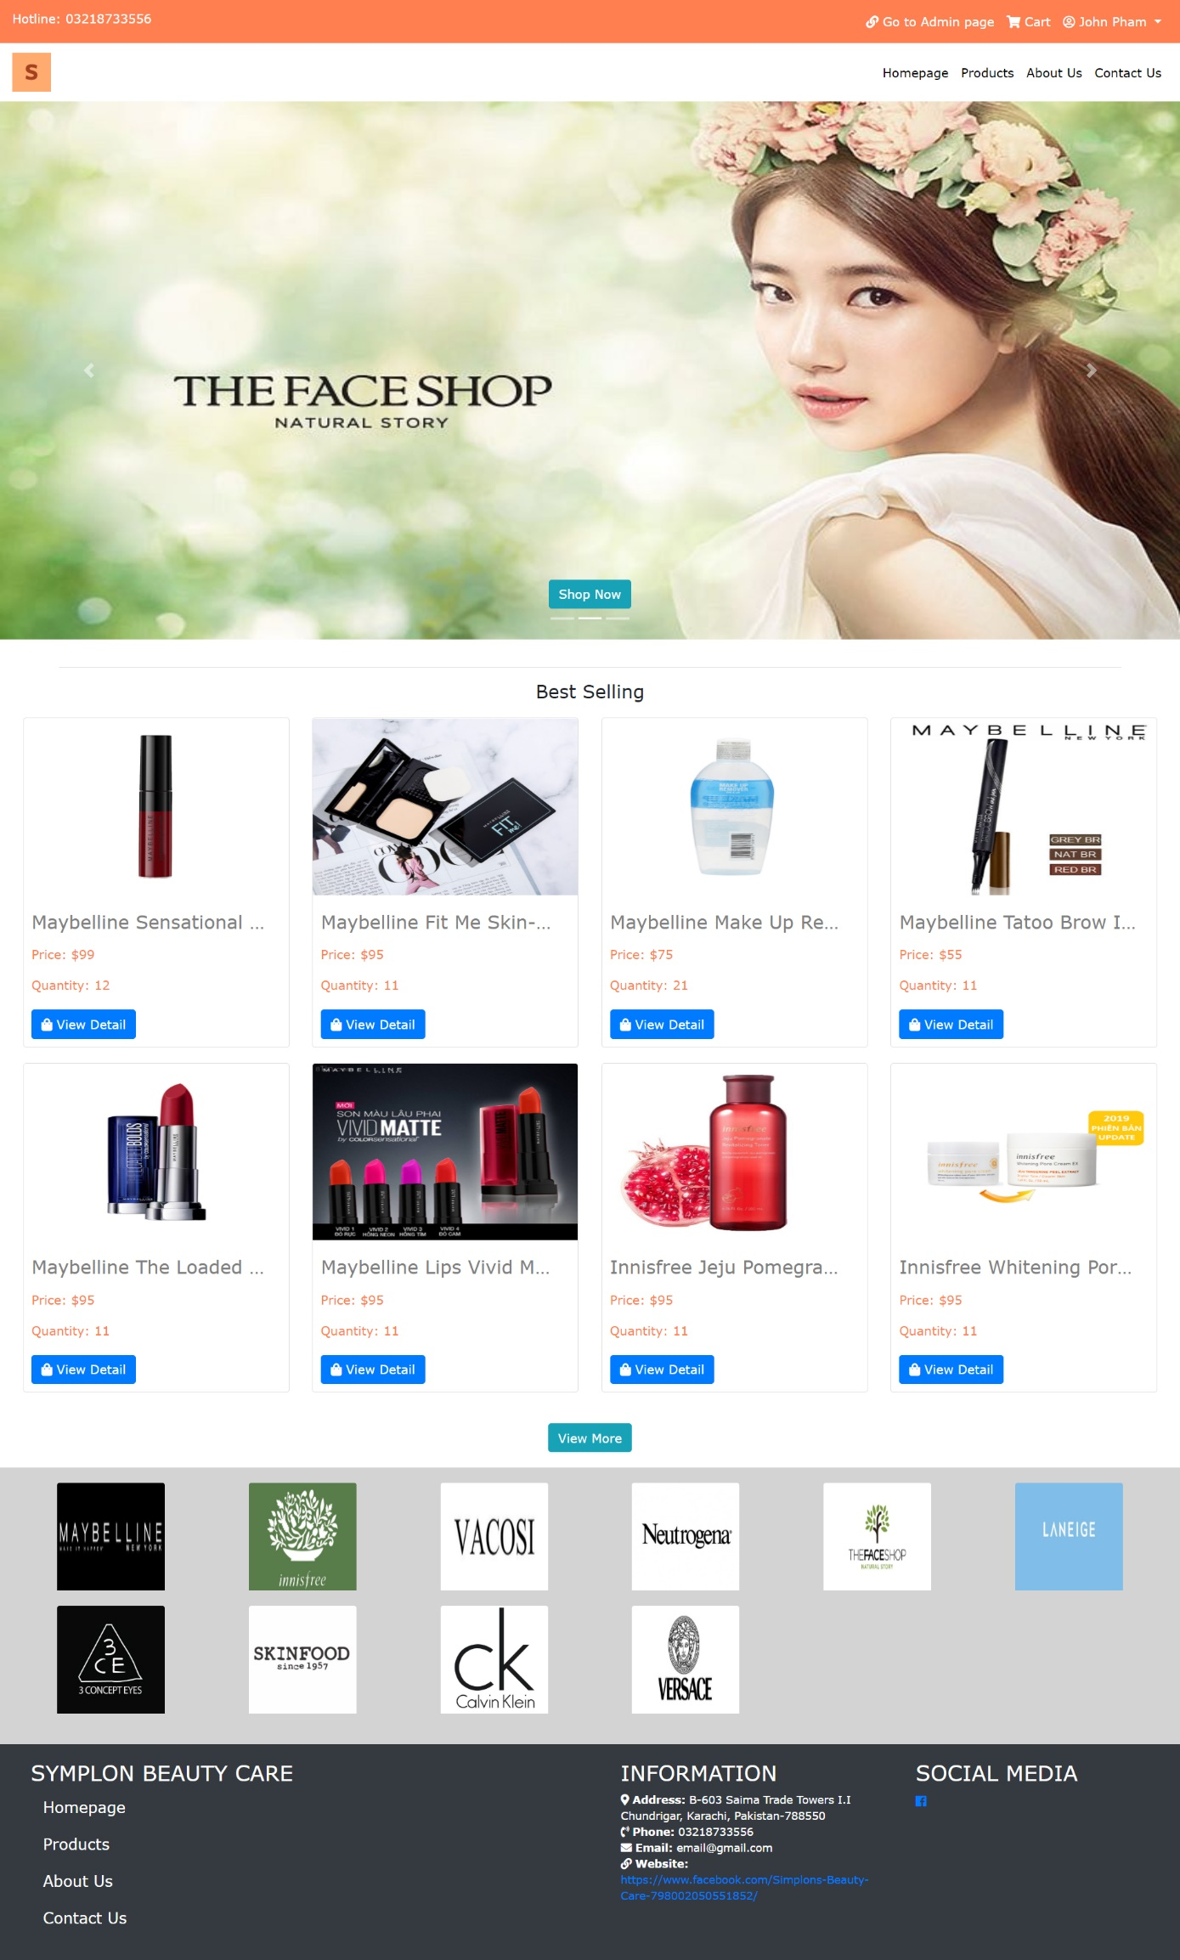

|  |  |
| --- | --- |
| **Operation No.** | **Description** |
| 1 | Click on this option will direct user to the administration site |

1. ***Manage Staff (Administrators)***
2. **Description:**

* User can manage all administrators via this feature:
  + View list of staffs
  + Create new staff
  + Update staff’s information
  + Delete staff

1. **Design and Operation:**

* **View list of staff:** user can view list of all administrators in the system (super administrator excluded).

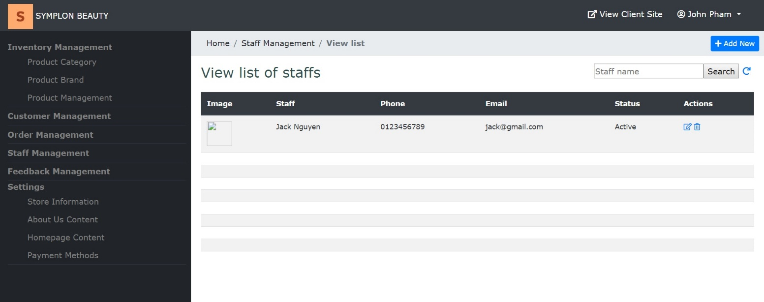

|  |  |
| --- | --- |
| **Operation No.** | **Description** |
| 1 | Click on this option will direct user to the page displaying list of administrators |

* **Create new staff:** user can create new administrator by clicking on “Add New” button on the list page.

**<**image here**>**

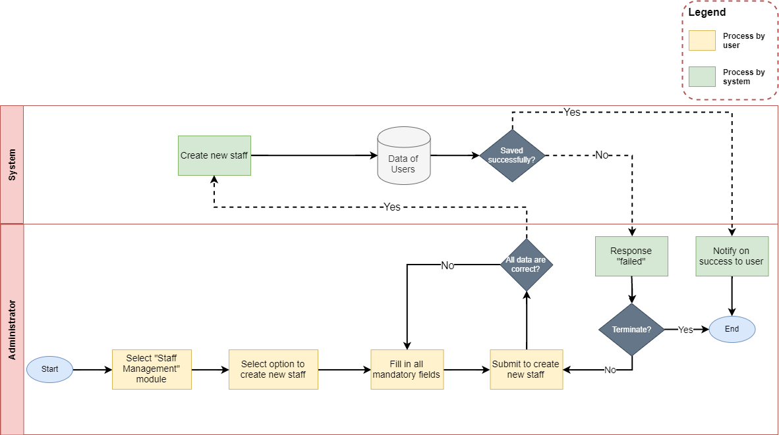

* + To finish creating new administrator, user needs to input all mandatory fields on the form:

|  |  |
| --- | --- |
| **Fields** | **Description** |
| Photo | * This field is not mandatory. * User can upload the photo to use as administrator’s avatar. * User can only upload image file with current supported extension as: .png .gif .jpge .jpg. * User can only upload image file whose size is not larger than 5MB. |
| Name | * This field is mandatory. * Name will be display throughout the website. |
| Pin Code | * This field is mandatory. * Pin Code will be used as security code to reset administrator’s password. Therefore, it is only shown when user register a new account, there is no other place where this value will be shown. |
| Username | * This field is mandatory. * This field will be used as login credential along with administrator’s password. * Username can only contain alphabet and digit character, cannot include space or special character. * Username must be unique in the system. |
| Gender | * This field is mandatory. * Allow user to select administrator’s gender |
| Email | * This field is mandatory. * Allow user to input administrator’s email. Email format must be correct. |
| Phone | * This field is not mandatory. * Allow user to input administrator’s phone |
| Date of birth | * This field is mandatory. * Allow user to select administrator’s birthday |
| Address | * This field is not mandatory. * Allow user to input administrator’s address |

* When user submits to create new administrator and all the information are correct, administrator’s account will be created in the system with role as “administrator” and default password as “abc123”.
* **Update staff’s information:** user can update the information of one administrator by clicking on “Edit” icon on the list page.

**<**image here**>**

* + To finish updating the information of the administrator, user needs to make sure all mandatory fields on the form are filled in:

|  |  |
| --- | --- |
| **Fields** | **Description** |
| Photo | * This field is not mandatory. * User can upload the photo to use as administrator’s avatar. * User can only upload image file with current supported extension as: .png .gif .jpge .jpg. * User can only upload image file whose size is not larger than 5MB. |
| Name | * This field is mandatory. * Name will be display throughout the website. |
| Pin Code | * This field is mandatory. * Pin Code will be used as security code to reset administrator’s password. Therefore, it is only shown when user create a new account, there is no other place where this value will be shown. |
| Status | * This field is mandatory. * Allow user to select the status for the administrator. If the administrator has status as inactive, he/ she cannot login the system anymore |
| Username | * This field is read only, cannot be updated. |
| Gender | * This field is mandatory. * Allow user to select administrator’s gender |
| Email | * This field is mandatory. * Allow user to input administrator’s email. Email format must be correct. |
| Phone | * This field is not mandatory. * Allow user to input administrator’s phone |
| Date of birth | * This field is mandatory. * Allow user to select administrator’s birthday |
| Address | * This field is not mandatory. * Allow user to input administrator’s address |

* When user submits to update the information of the administrator and all the information are correct, administrator’s information will be updated in the system.
* **Delete staff:** user can delete the administrator by clicking on “Delete” icon on the list page or “Delete” button on the Edit Detail page.

**<**image here**>**

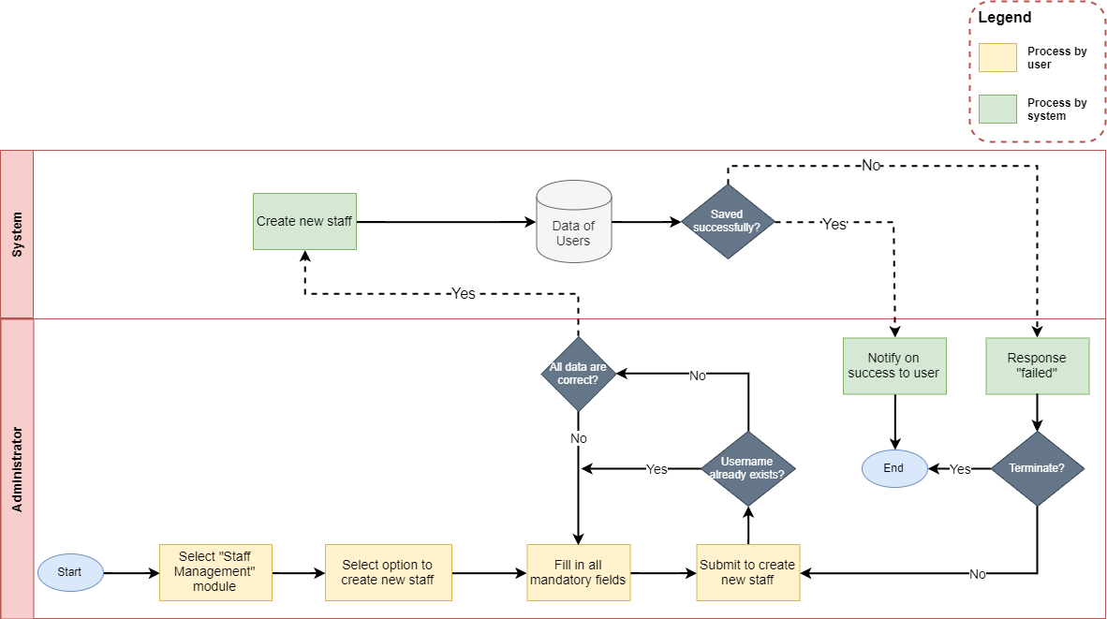

|  |  |
| --- | --- |
| **Operation No.** | **Description** |
| 1 | Click on this option will show confirmation message if user actually wants to delete the selected administrator. If user selects to proceed, the selected administrator will be deleted and that administrator will not be able to login the system anymore. |

1. ***Manage Product Brand***
2. **Description:**

* User can manage all product brands via this feature:
  + View list of product brands
  + Create new product brand
  + Update product brand’s information
  + Delete product brand

1. **Design and Operation:**

* **View list of product brand:** user can view list of all product brands in the system.

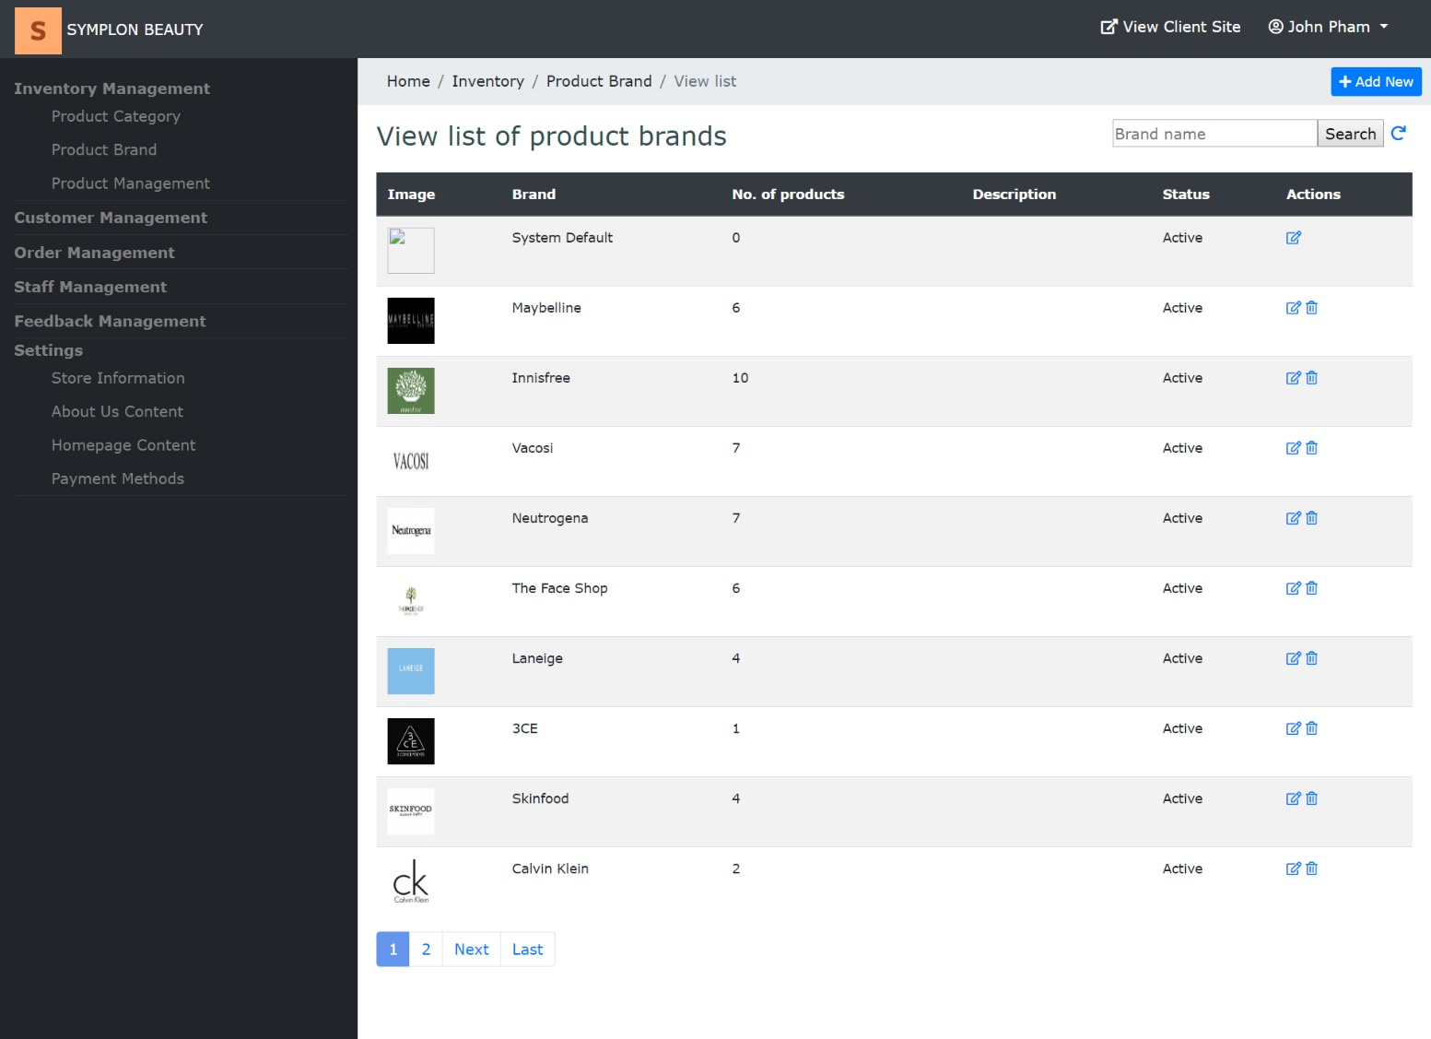

|  |  |
| --- | --- |
| **Operation No.** | **Description** |
| 1 | Click on this option will direct user to the page displaying list of product brands |

* **Create new product brand:** user can create new product brand by clicking on “Add New” button on the list page.

**<**image here**>**

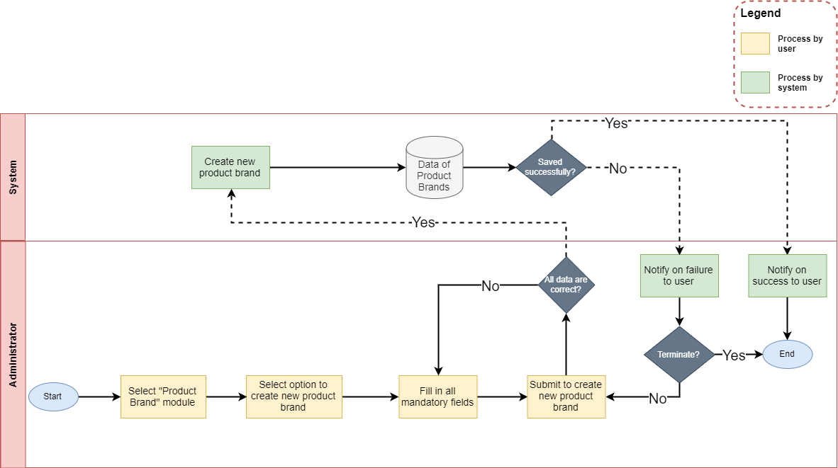

* + To finish creating new product brand, user needs to input all mandatory fields on the form:

|  |  |
| --- | --- |
| **Fields** | **Description** |
| Photo | * This field is not mandatory. * User can upload the photo to use as product brand’s image. * User can only upload image file with current supported extension as: .png .gif .jpge .jpg. * User can only upload image file whose size is not larger than 5MB. |
| Name | * This field is mandatory. * Name of product brand will be display throughout the website. |
| Description | * This field is not mandatory. * Allow user to input product brand’s description |

* When user submits to create new product brand and all the information are correct, the product brand will be created in the system.
* **Update product brand’s information:** user can update the information of one product brand by clicking on “Edit” icon on the list page.

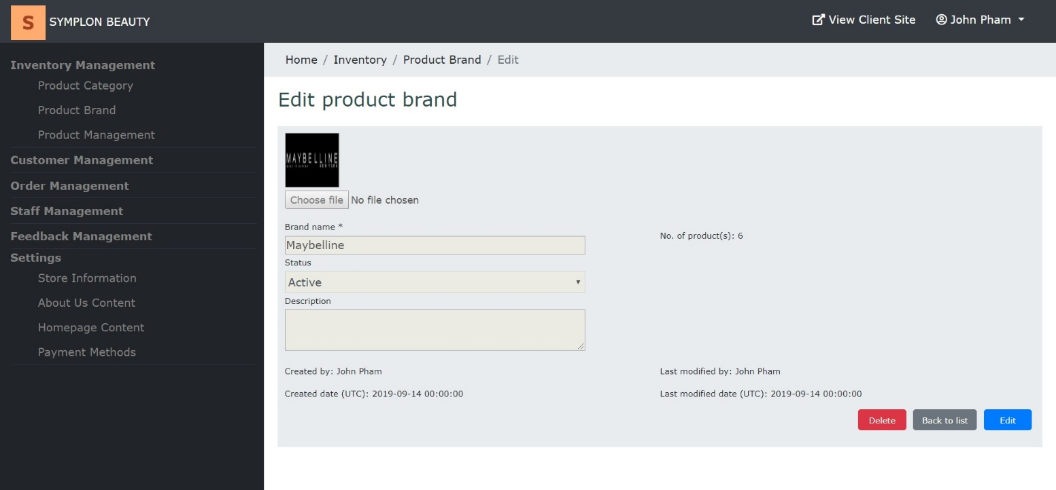

* + To finish updating the information of the product brand, user needs to make sure all mandatory fields on the form are filled in:

|  |  |
| --- | --- |
| **Fields** | **Description** |
| Photo | * This field is not mandatory. * User can upload the photo to use as product brand’s image. * User can only upload image file with current supported extension as: .png .gif .jpge .jpg. * User can only upload image file whose size is not larger than 5MB. |
| Name | * This field is mandatory. * Name of product brand will be display throughout the website. |
| Status | * This field is mandatory. * Allow user to select the status for the product brand. |
| Description | * This field is not mandatory. * Allow user to input product brand’s description |

* When user submits to update the information of the product brand and all the information are correct, product brand’s information will be updated in the system.
* **Delete product brand:** user can delete the product brand by clicking on “Delete” icon on the list page or “Delete” button on the Edit Detail page (product brand with type as “system default brand” is excluded).

**<**image here**>**

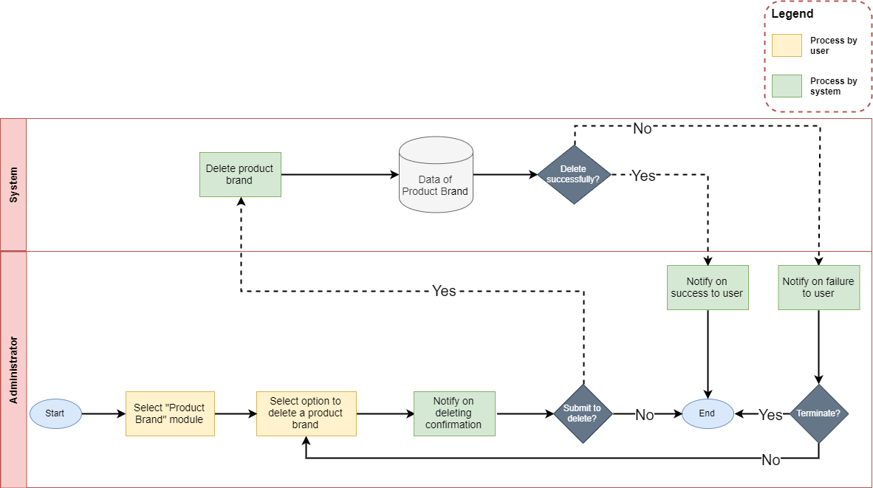

|  |  |
| --- | --- |
| **Operation No.** | **Description** |
| 1 | Click on this option will show confirmation message if user actually wants to delete the selected product brand. If user selects to proceed, the selected product brand will be deleted and all products belong to that product brand will be set to “System default brand” automatically. |

1. ***Manage Product Category***
2. **Description:**

* User can manage all product categories via this feature:
  + View list of product categories
  + Create new product category
  + Update product category’s information
  + Delete product category

1. **Design and Operation:**

* **View list of product category:** user can view list of all product categories in the system.

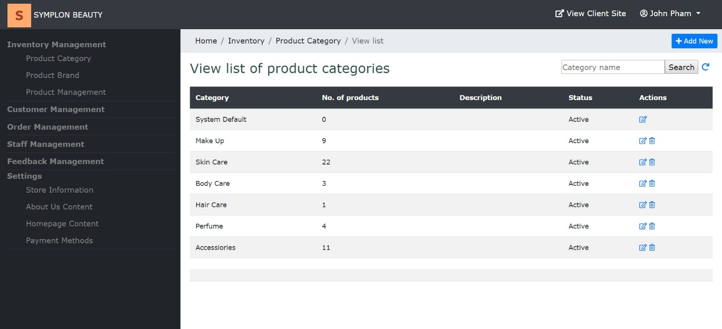

|  |  |
| --- | --- |
| **Operation No.** | **Description** |
| 1 | Click on this option will direct user to the page displaying list of product categories |

* **Create new category:** user can create new product category by clicking on “Add New” button on the list page.

**<**image here**>**

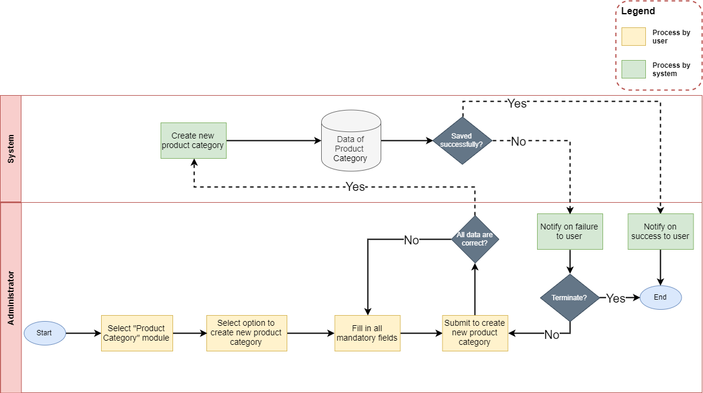

* + To finish creating new product category, user needs to input all mandatory fields on the form:

|  |  |
| --- | --- |
| **Fields** | **Description** |
| Name | * This field is mandatory. * Name of product category will be display throughout the website. |
| Description | * This field is not mandatory. * Allow user to input product category’s description |

* When user submits to create new product category and all the information are correct, the product category will be created in the system.
* **Update product category’s information:** user can update the information of one product category by clicking on “Edit” icon on the list page.

**<**image here**>**

* + To finish updating the information of the product category, user needs to make sure all mandatory fields on the form are filled in:

|  |  |
| --- | --- |
| **Fields** | **Description** |
| Name | * This field is mandatory. * Name of product category will be display throughout the website. |
| Status | * This field is mandatory. * Allow user to select the status for the product category. |
| Description | * This field is not mandatory. * Allow user to input product category’s description |

* When user submits to update the information of the product category and all the information are correct, product category’s information will be updated in the system.
* **Delete product category:** user can delete the product category by clicking on “Delete” icon on the list page or “Delete” button on the Edit Detail page (product category with type as “system default category” is excluded).

**<**image here**>**

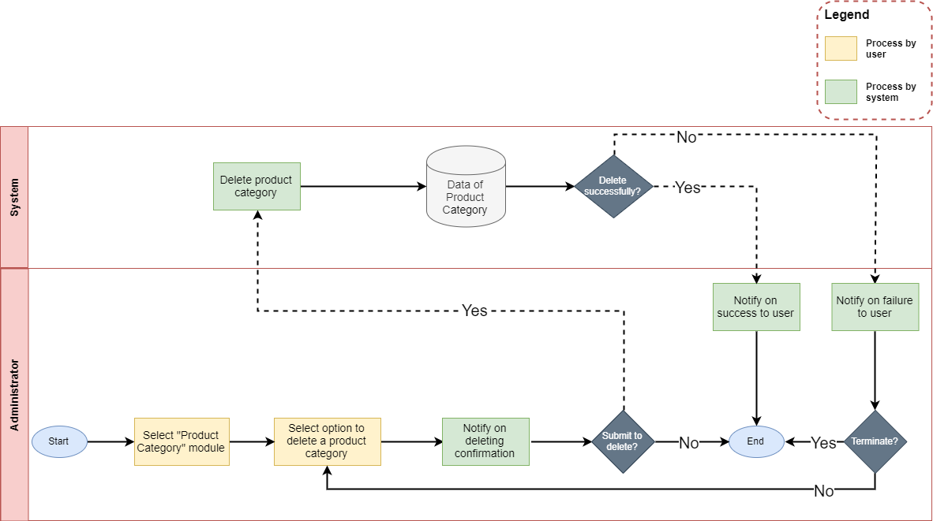

|  |  |
| --- | --- |
| **Operation No.** | **Description** |
| 1 | Click on this option will show confirmation message if user actually wants to delete the selected product category. If user selects to proceed, the selected product category will be deleted and all products belong to that product category will be set to “System default category” automatically. |

1. ***Manage Product***
2. **Description:**

* User can manage all products via this feature:
  + View list of products
  + Create new product
  + Update product’s information
  + Delete product

1. **Design and Operation:**

* **View list of product:** user can view list of all products in the system.

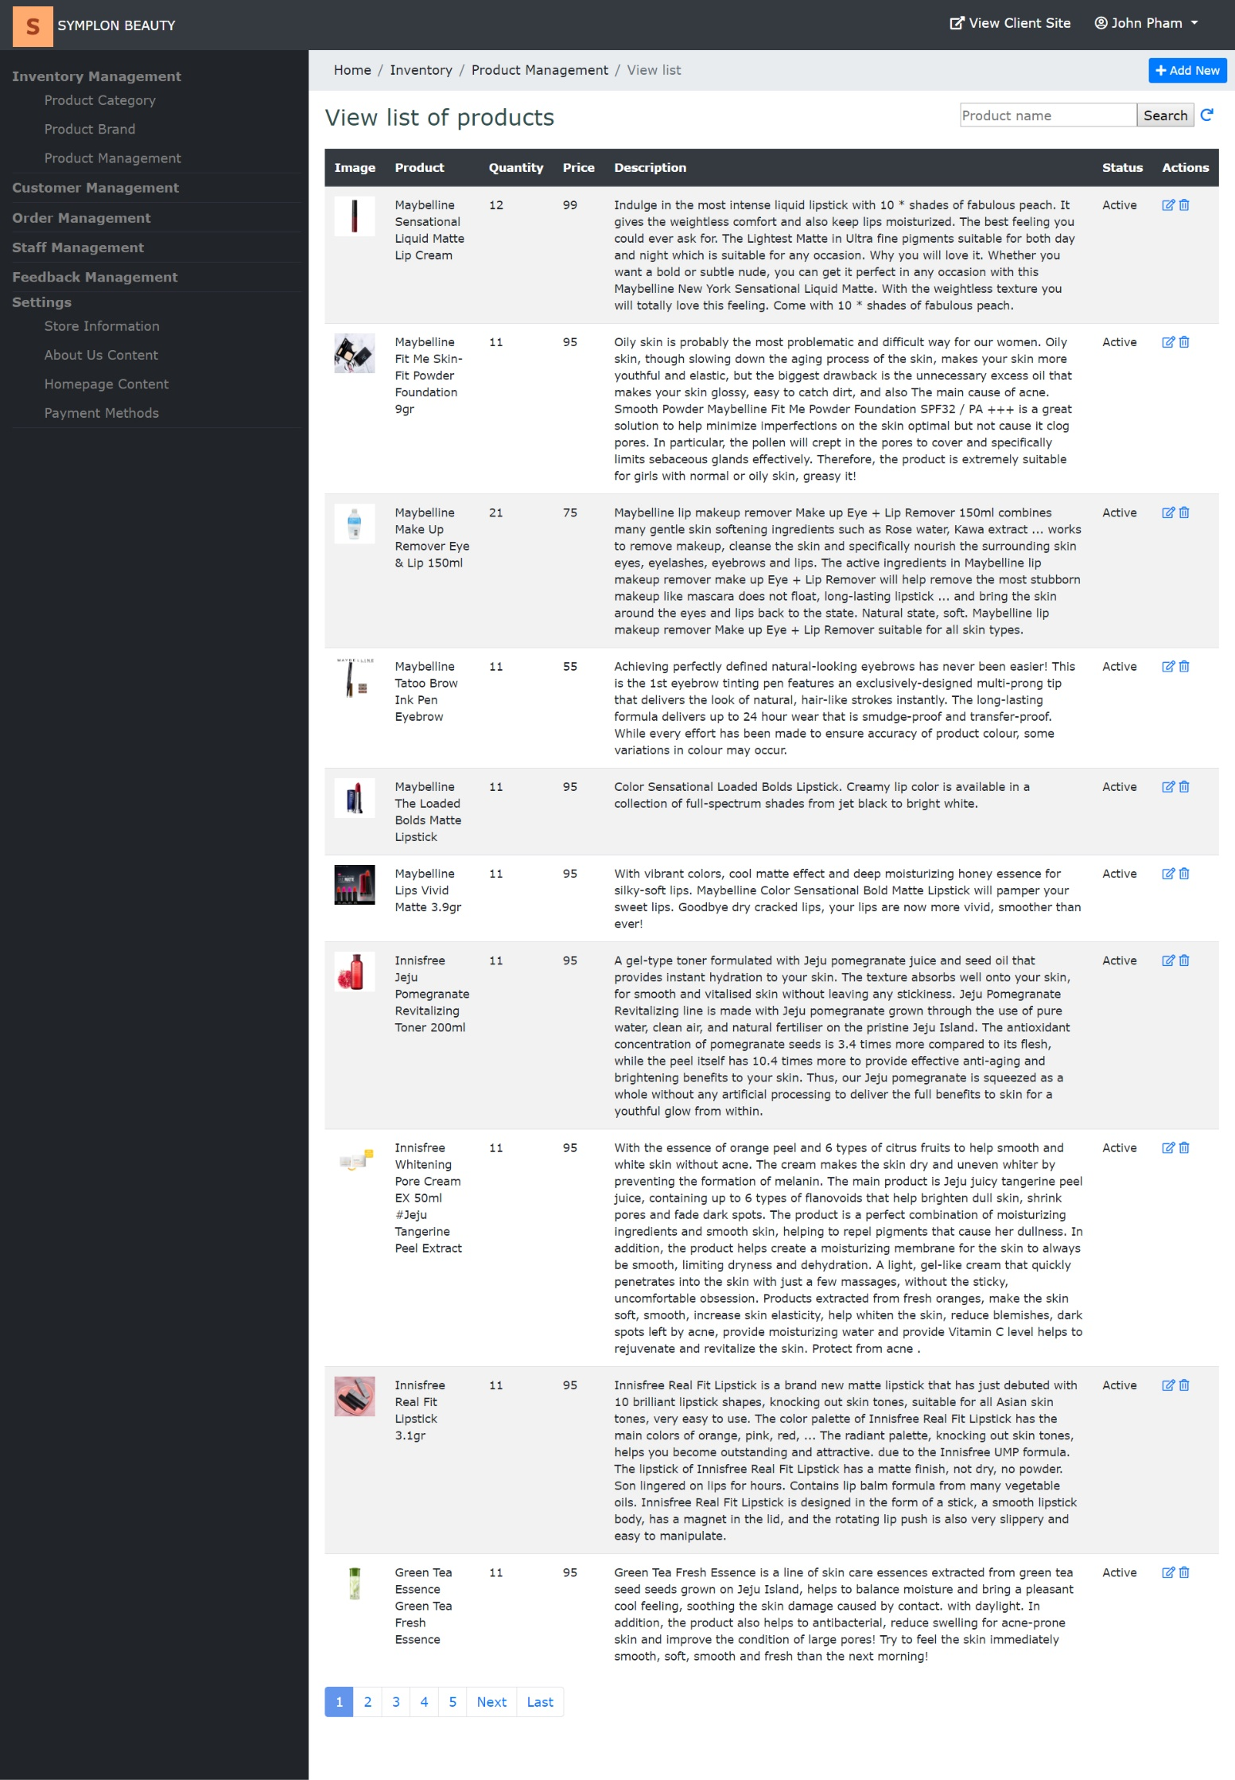

|  |  |
| --- | --- |
| **Operation No.** | **Description** |
| 1 | Click on this option will direct user to the page displaying list of products |

* **Create new product:** user can create new product by clicking on “Add New” button on the list page.

**<**image here**>**

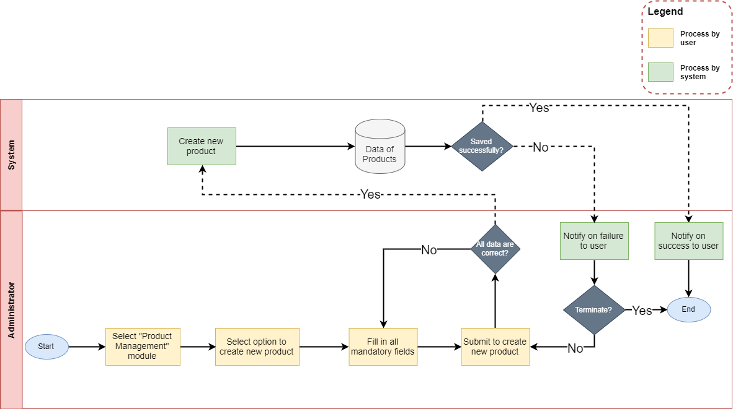

* + To finish creating new product, user needs to input all mandatory fields on the form:

|  |  |
| --- | --- |
| **Fields** | **Description** |
| Photo | * This field is mandatory. * User can upload the photo to use as product’s image. * User can only upload image file with current supported extension as: .png .gif .jpge .jpg. * User can only upload image file whose size is not larger than 5MB. |
| Name | * This field is mandatory. * Name will be display throughout the website. |
| Brand | * This field is mandatory. * Allow user to select brand which the product belongs to. |
| Category | * This field is mandatory. * Allow user to select category which the product belongs to. |
| Price | * This field is mandatory. * Allow user to input the price for the product |
| Quantity | * This field is mandatory. * Allow user to input the quantity/ stock for the product. This quantity will be updated real time whenever customer buy the product |
| Description | * This field is not mandatory. * Allow user to input product’s description |

* When user submits to create new product and all the information are correct, product will be created in the system.
* **Update product’s information:** user can update the information of one product by clicking on “Edit” icon on the list page.

**<**image here**>**

* + To finish updating the information of the product, user needs to make sure all mandatory fields on the form are filled in:

|  |  |
| --- | --- |
| **Fields** | **Description** |
| Photo | * This field is mandatory. * User can upload the photo to use as product’s image. * User can only upload image file with current supported extension as: .png .gif .jpge .jpg. * User can only upload image file whose size is not larger than 5MB. |
| Name | * This field is mandatory. * Name will be display throughout the website. |
| Status | * This field is mandatory. * Allow user to select the status for the product |
| Brand | * This field is mandatory. * Allow user to select brand which the product belongs to. |
| Category | * This field is mandatory. * Allow user to select category which the product belongs to. |
| Price | * This field is mandatory. * Allow user to input the price for the product |
| Quantity | * This field is mandatory. * Allow user to input the quantity/ stock for the product. This quantity will be updated real time whenever customer buy the product |
| Description | * This field is not mandatory. * Allow user to input product’s description |

* When user submits to update the information of the product and all the information are correct, product’s information will be updated in the system.
* **Delete product:** user can delete the product by clicking on “Delete” icon on the list page or “Delete” button on the Edit Detail page.

**<**image here**>**

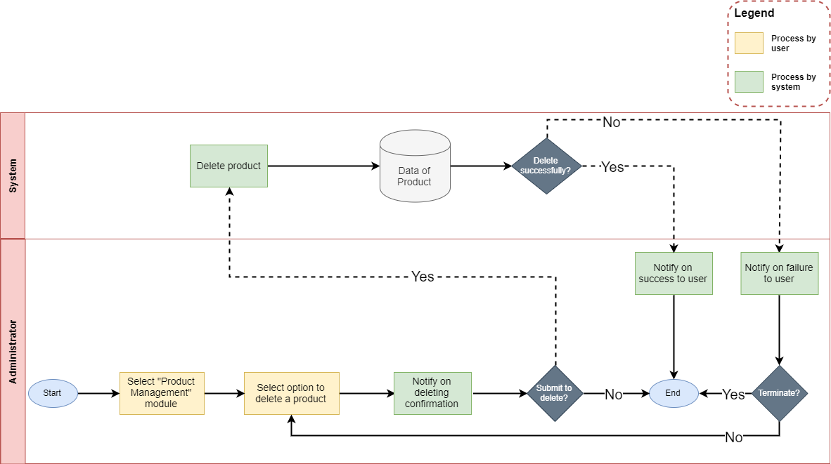

|  |  |
| --- | --- |
| **Operation No.** | **Description** |
| 1 | Click on this option will show confirmation message if user actually wants to delete the selected product. If user selects to proceed, the selected product will be deleted and will not be shown on Customer Site anymore. |

1. ***Manage Customer***
2. **Description:**

* User can manage all customers via this feature:
  + View list of customers
  + Create new customer
  + Update customer’s information
  + Delete customer

1. **Design and Operation:**

* **View list of customer:** user can view list of all customers in the system.

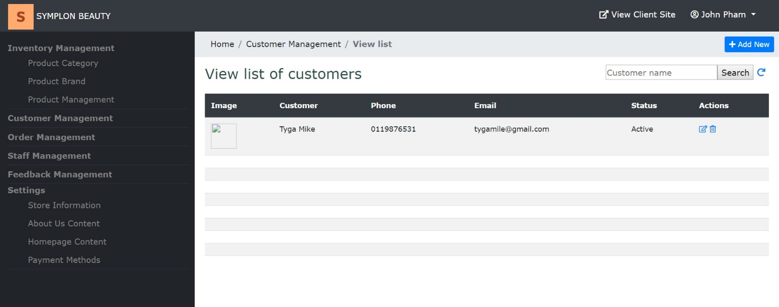

|  |  |
| --- | --- |
| **Operation No.** | **Description** |
| 1 | Click on this option will direct user to the page displaying list of customers |

* **Create new customer:** user can create new customer by clicking on “Add New” button on the list page.

**<**image here**>**

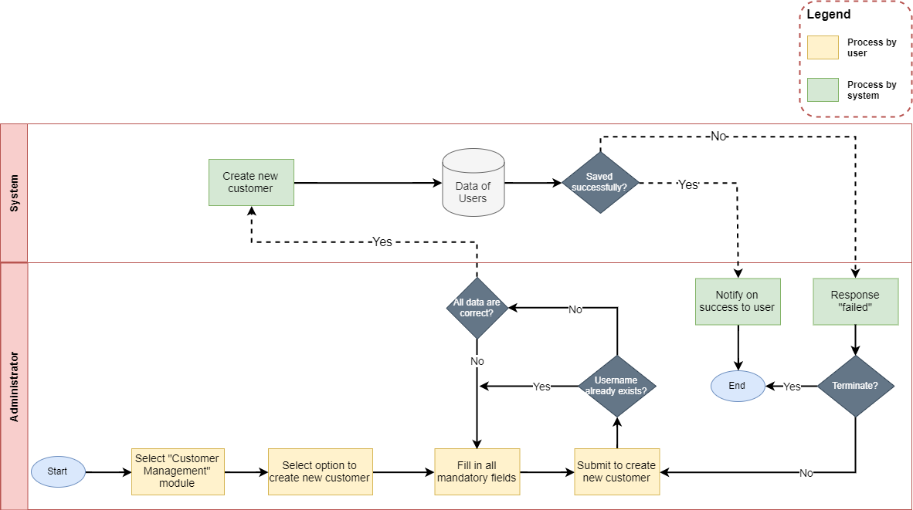

* + To finish creating new customer, user needs to input all mandatory fields on the form:

|  |  |
| --- | --- |
| **Fields** | **Description** |
| Photo | * This field is not mandatory. * User can upload the photo to use as customer’s avatar. * User can only upload image file with current supported extension as: .png .gif .jpge .jpg. * User can only upload image file whose size is not larger than 5MB. |
| Name | * This field is mandatory. * Name will be display throughout the website. |
| Pin Code | * This field is mandatory. * Pin Code will be used as security code to reset customer’s password. Therefore, it is only shown when user create a new account, there is no other place where this value will be shown. |
| Username | * This field is mandatory. * This field will be used as login credential along with customer’s password. * Username can only contain alphabet and digit character, cannot include space or special character. * Username must be unique in the system. |
| Gender | * This field is mandatory. * Allow user to select customer’s gender |
| Email | * This field is mandatory. * Allow user to input customer’s email. Email format must be correct. |
| Phone | * This field is not mandatory. * Allow user to input customer’s phone |
| Date of birth | * This field is mandatory. * Allow user to select customer’s birthday |
| Address | * This field is not mandatory. * Allow user to input customer’s address |

* When user submits to create new customer and all the information are correct, customer’s account will be created in the system with default password as “abc123”.
* **Update customer’s information:** user can update the information of one customer by clicking on “Edit” icon on the list page.

**<**image here**>**

* + To finish updating the information of the customer, user needs to make sure all mandatory fields on the form are filled in:

|  |  |
| --- | --- |
| **Fields** | **Description** |
| Photo | * This field is not mandatory. * User can upload the photo to use as customer’s avatar. * User can only upload image file with current supported extension as: .png .gif .jpge .jpg. * User can only upload image file whose size is not larger than 5MB. |
| Name | * This field is mandatory. * Name will be display throughout the website. |
| Pin Code | * This field is mandatory. * Pin Code will be used as security code to reset customer’s password. Therefore, it is only shown when user create a new account, there is no other place where this value will be shown. |
| Status | * This field is mandatory. * Allow user to select the status for the customer. If the customer has status as inactive, he/ she cannot login the system anymore |
| Username | * This field is read only, cannot be updated. |
| Gender | * This field is mandatory. * Allow user to select customer’s gender |
| Email | * This field is mandatory. * Allow user to input customer’s email. Email format must be correct. |
| Phone | * This field is not mandatory. * Allow user to input customer’s phone |
| Date of birth | * This field is mandatory. * Allow user to select customer’s birthday |
| Address | * This field is not mandatory. * Allow user to input customer’s address |

* When user submits to update the information of the customer and all the information are correct, customer’s information will be updated in the system.
* **Delete customer:** user can delete the customer by clicking on “Delete” icon on the list page or “Delete” button on the Edit Detail page.

**<**image here**>**

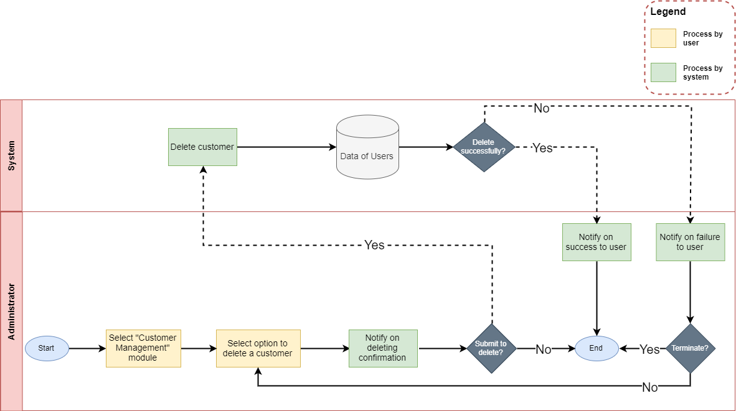

|  |  |
| --- | --- |
| **Operation No.** | **Description** |
| 1 | Click on this option will show confirmation message if user actually wants to delete the selected customer. If user selects to proceed, the selected customer will be deleted and that customer will not be able to login the system anymore. |

1. ***Manage Order***
2. **Description:**

* User can manage all orders via this feature:
  + View list of orders
  + View detail of order
  + Delete order

1. **Design and Operation:**

* **View list of orders:** user can view list of all orders in the system.

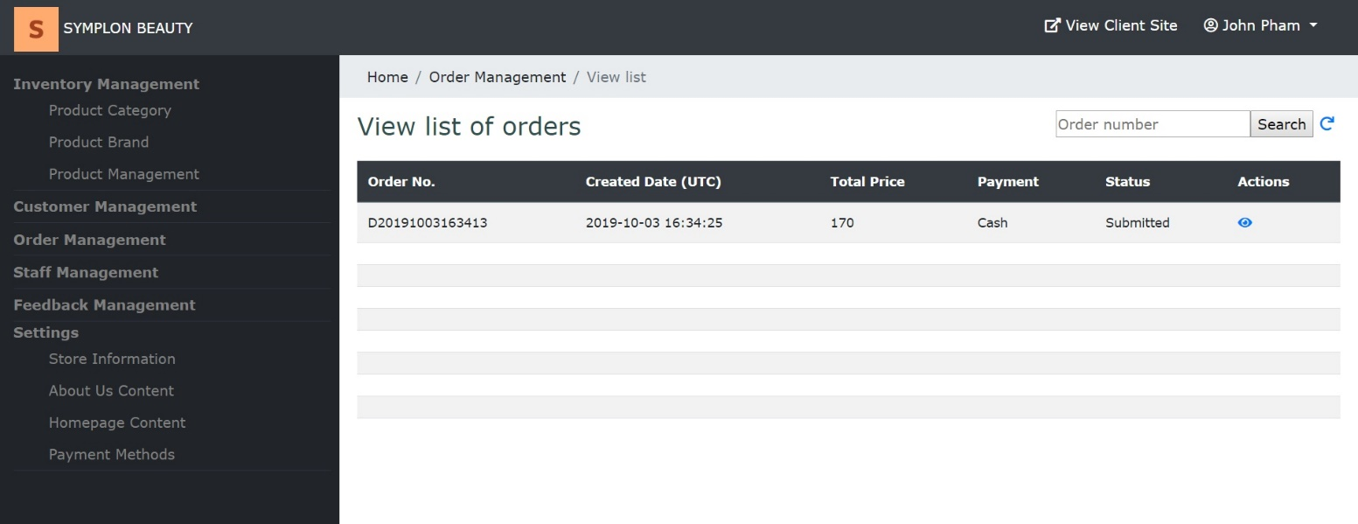

|  |  |
| --- | --- |
| **Operation No.** | **Description** |
| 1 | Click on this option will direct user to the page displaying list of orders |

* **View order’s detail:** user can view detail of one order by clicking on “View” icon on the list page.

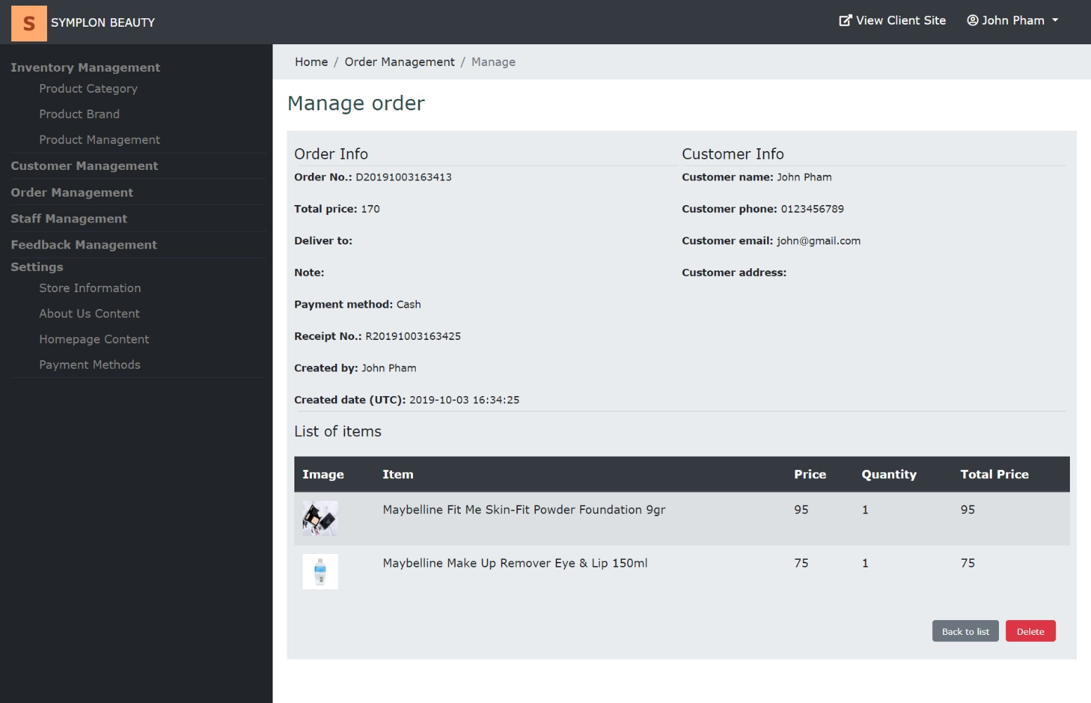

|  |  |
| --- | --- |
| **Operation No.** | **Description** |
| 1 | Click on this option will direct user to the page displaying detail of the orders |

* **Delete order:** user can delete the order by clicking on “Delete” icon on the list page or “Delete” button on the Edit Detail page.

**<**image here**>**

|  |  |
| --- | --- |
| **Operation No.** | **Description** |
| 1 | Click on this option will show confirmation message if user actually wants to delete the selected order. If user selects to proceed, the selected order will be deleted and the quantity of all products in the order will be returned to them own. |

1. ***Manage Feedback***
2. **Description:**

* User can manage all feedbacks via this feature:
  + View list of feedbacks
  + Acknowledge feedback
  + Reject feedback

1. **Design and Operation:**

* **View list of feedbacks:** user can view list of all feedbacks in the system.

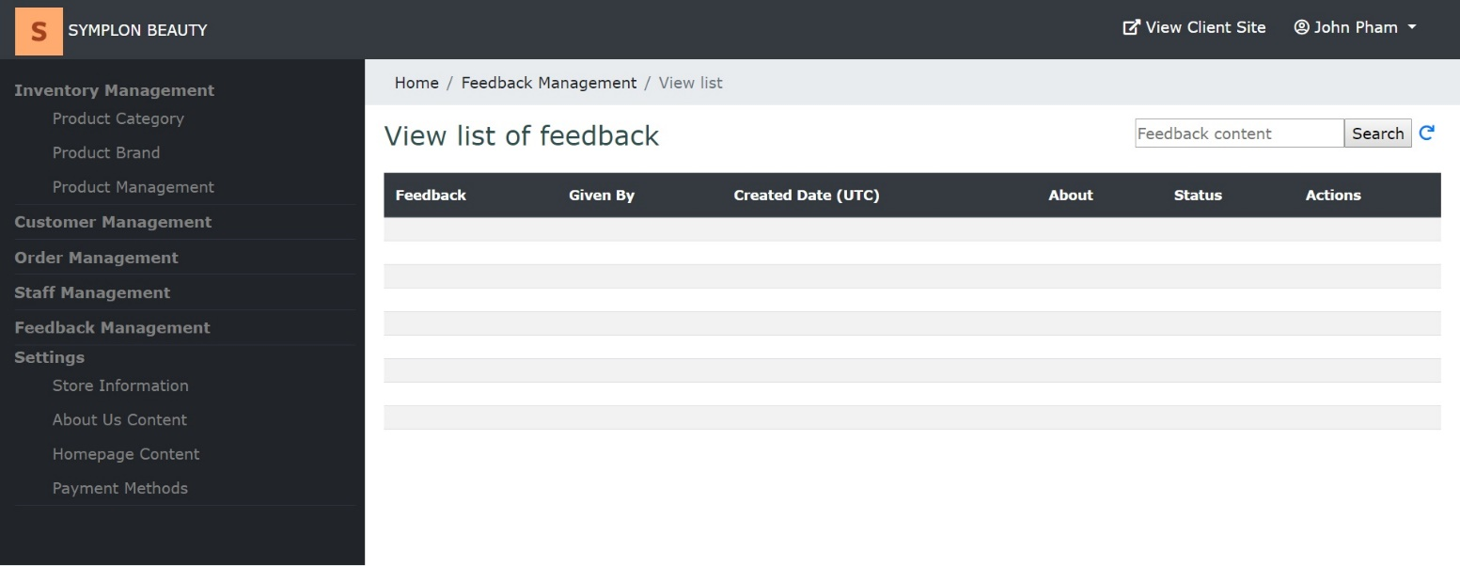

|  |  |
| --- | --- |
| **Operation No.** | **Description** |
| 1 | Click on this option will direct user to the page displaying list of feedbacks |

* **Acknowledge feedback:** user can approve new feedback by clicking on “Acknowledged” icon on the list page.

**<**image here**>**

|  |  |
| --- | --- |
| **Operation No.** | **Description** |
| 1 | Click on this option will change the feedback status to “Acknowledged” |

* **Reject feedback:** user can rejct new feedback by clicking on “Reject” icon on the list page.

**<**image here**>**

|  |  |
| --- | --- |
| **Operation No.** | **Description** |
| 1 | Click on this option will change the feedback status to “Rejected”. Rejected feedback will no longer be shown on UI |

1. ***Manage Payment Method***
2. **Description:**

* User can manage all payment methods via this feature:
  + View list of payment methods
  + Create new payment method
  + Update payment method’s information
  + Delete payment method

1. **Design and Operation:**

* **View list of payment methods:** user can view list of all payment methods in the system.

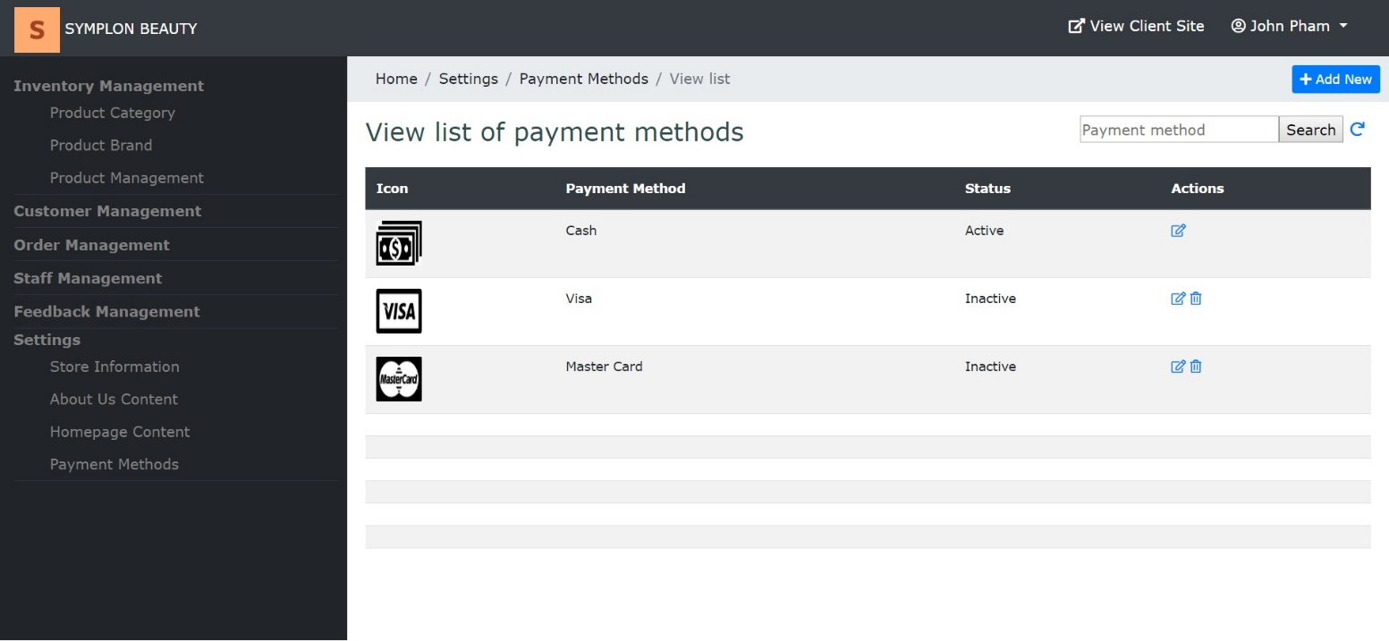

|  |  |
| --- | --- |
| **Operation No.** | **Description** |
| 1 | Click on this option will direct user to the page displaying list of payment methods |

* **Create new payment method**:user can create new payment methodby clicking on “Add New” button on the list page.

**<**image here**>**

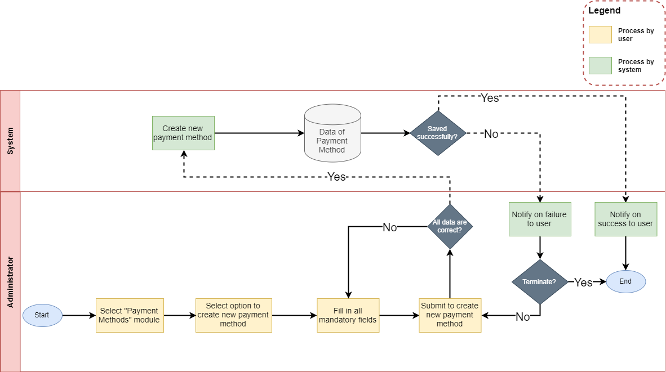

* + To finish creating new payment method, user needs to input all mandatory fields on the form:

|  |  |
| --- | --- |
| **Fields** | **Description** |
| Photo | * This field is not mandatory. * User can upload the photo to use as payment method’s image. * User can only upload image file with current supported extension as: .png .gif .jpge .jpg. * User can only upload image file whose size is not larger than 5MB. |
| Name | * This field is mandatory. * Name will be display throughout the website. |

* When user submits to create new payment method and all the information are correct, payment method will be created in the system.
* **Update payment method’s information:** user can update the information of one payment method by clicking on “Edit” icon on the list page.

**<**image here**>**

* + To finish updating the information of the payment method, user needs to make sure all mandatory fields on the form are filled in:

|  |  |
| --- | --- |
| **Fields** | **Description** |
| Photo | * This field is not mandatory. * User can upload the photo to use as customer’s avatar. * User can only upload image file with current supported extension as: .png .gif .jpge .jpg. * User can only upload image file whose size is not larger than 5MB. |
| Name | * This field is mandatory. * Name will be display throughout the website. |
| Status | * This field is mandatory. * Allow user to select the status for the payment method. |

* When user submits to update the information of the payment method and all the information are correct, payment method’s information will be updated in the system.
* **Delete payment method:** user can delete the payment method by clicking on “Delete” icon on the list page or “Delete” button on the Edit Detail page.

**<**image here**>**

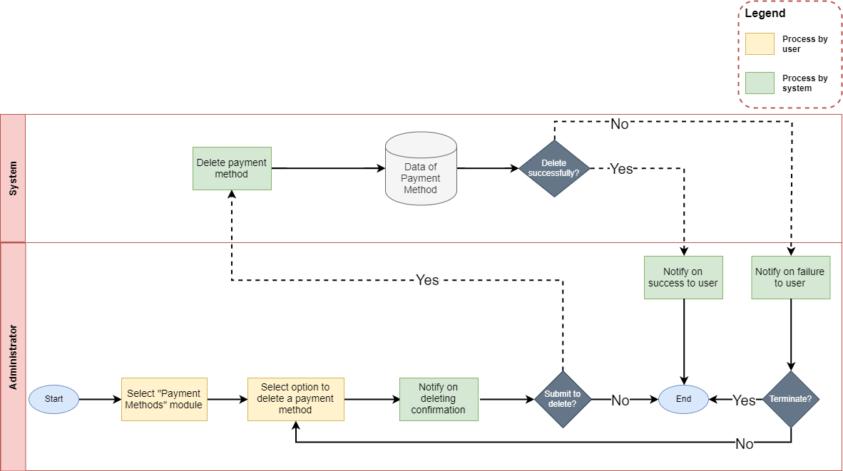

|  |  |
| --- | --- |
| **Operation No.** | **Description** |
| 1 | Click on this option will show confirmation message if user actually wants to delete the selected payment method. If user selects to proceed, the selected payment methodwill be deleted. |

1. ***Manage Homepage Content***
2. **Description:**

* User can manage all homepage images via this feature:
  + View list of homepage images
  + Update homepage image

1. **Design and Operation:**

* **View list of homepage images:** user can view list of all homepage images in the system.

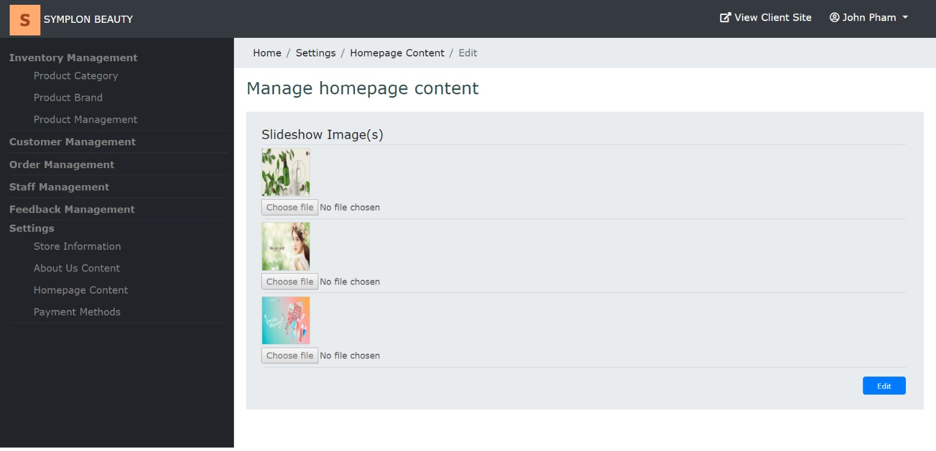

|  |  |
| --- | --- |
| **Operation No.** | **Description** |
| 1 | Click on this option will direct user to the page displaying list of homepage images |

* **Update homepage images:** user can update the homepage images by clicking on “Edit” icon on the list page.

**<**image here**>**

* + To finish updating the homepage images, user needs to make sure all mandatory fields on the form are filled in:

|  |  |
| --- | --- |
| **Fields** | **Description** |
| Photo | * This field is not mandatory. * User can upload the photo to use as homepage images. * User can only upload image file with current supported extension as: .png .gif .jpge .jpg. * User can only upload image file whose size is not larger than 5MB. |

* When user submits to update the homepage images and all the information are correct, homepage images will be updated in the system.

1. ***Manage Store Information***
2. **Description:**

* User can manage all stores via this feature:
  + View list of stores
  + Create new store
  + Update store’s information
  + Delete store

1. **Design and Operation:**

* **View list of store:** user can view list of all stores in the system.

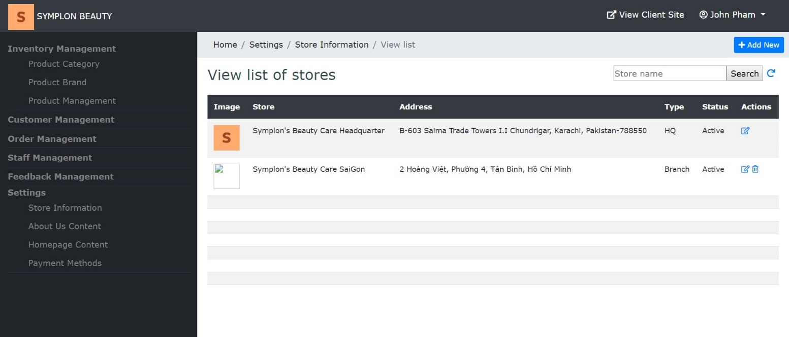

|  |  |
| --- | --- |
| **Operation No.** | **Description** |
| 1 | Click on this option will direct user to the page displaying list of stores |

* **Create new store:** user can create new store by clicking on “Add New” button on the list page.

**<**image here**>**

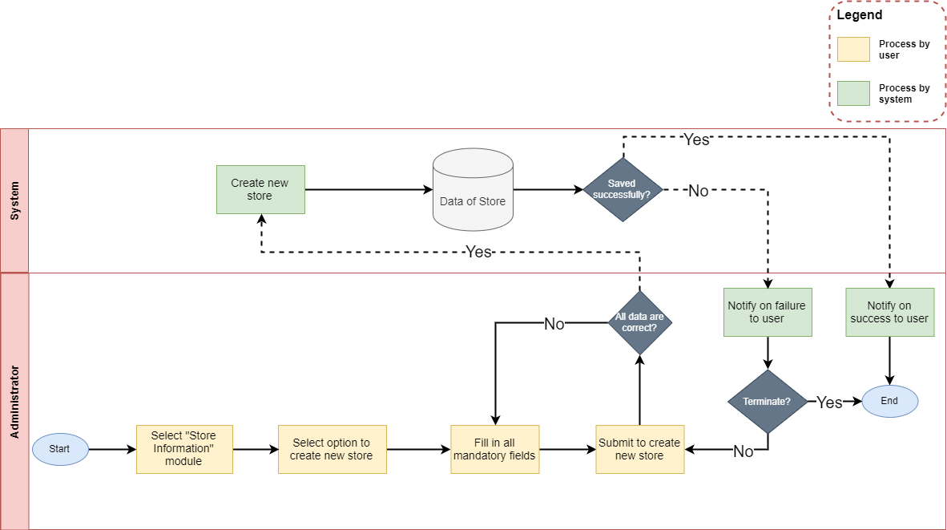

* + To finish creating new store, user needs to input all mandatory fields on the form:

|  |  |
| --- | --- |
| **Fields** | **Description** |
| Photo | * This field is not mandatory. * User can upload the photo to use as store’s image. * User can only upload image file with current supported extension as: .png .gif .jpge .jpg. * User can only upload image file whose size is not larger than 5MB. |
| Name | * This field is mandatory. * Name will be display throughout the website. * This field will be shown in “Contact Us” in Customer Site |
| Email | * This field is mandatory. * Allow user to input store’s email. Email format must be correct. * This field will be shown in “Contact Us” in Customer Site |
| Phone | * This field is not mandatory. * Allow user to input store’s phone * This field will be shown in “Contact Us” in Customer Site |
| Website | * This field is mandatory. * Allow user to select store’s birthday * This field will be shown in “Contact Us” in Customer Site |
| Address | * This field is mandatory. * Allow user to input store’s address * This field will be shown in “Contact Us” in Customer Site |

* When user submits to create new store and all the information are correct, store will be created in the system.
* **Update store’s information:** user can update the information of one store by clicking on “Edit” icon on the list page.

**<**image here**>**

* + To finish updating the information of the store, user needs to make sure all mandatory fields on the form are filled in:

|  |  |
| --- | --- |
| **Fields** | **Description** |
| Photo | * This field is not mandatory. * User can upload the photo to use as store’s image. * User can only upload image file with current supported extension as: .png .gif .jpge .jpg. * User can only upload image file whose size is not larger than 5MB. |
| Name | * This field is mandatory. * Name will be display throughout the website. * This field will be shown in “Contact Us” in Customer Site |
| Status | * This field is mandatory. * Allow user to select the status for the store. |
| Email | * This field is mandatory. * Allow user to input store’s email. Email format must be correct. * This field will be shown in “Contact Us” in Customer Site |
| Phone | * This field is not mandatory. * Allow user to input store’s phone * This field will be shown in “Contact Us” in Customer Site |
| Website | * This field is mandatory. * Allow user to select store’s birthday * This field will be shown in “Contact Us” in Customer Site |
| Address | * This field is mandatory. * Allow user to input store’s address * This field will be shown in “Contact Us” in Customer Site |

* When user submits to update the information of the store and all the information are correct, store ‘s information will be updated in the system.
* **Delete store:** user can delete the store by clicking on “Edit” icon on the list page or “Delete” button on the Edit Detail page (store with type as HQ is excluded).

**<**image here**>**

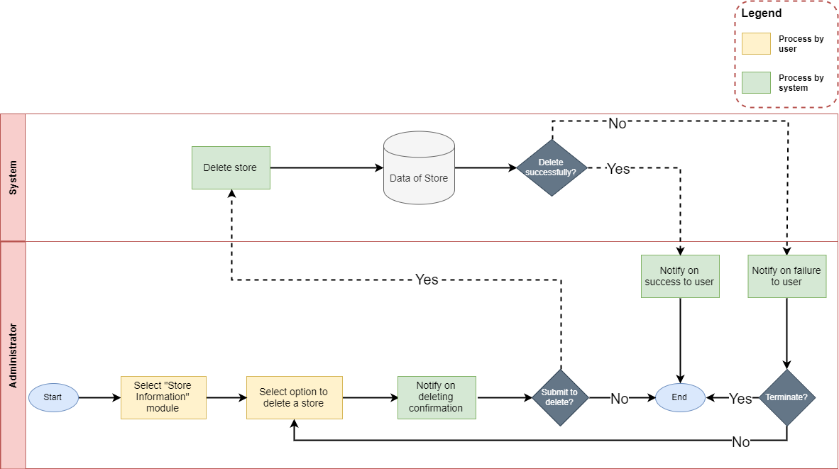

|  |  |
| --- | --- |
| **Operation No.** | **Description** |
| 1 | Click on this option will show confirmation message if user actually wants to delete the selected store. If user selects to proceed, the selected store will be deleted. |

1. ***Manage About Us Content***
2. **Description:**

* User can manage all About Us contents via this feature:
  + View list of About Us contents
  + Update About Us content

1. **Design and Operation:**

* **View list of About Us contents:** user can view list of all About Us contents in the system.

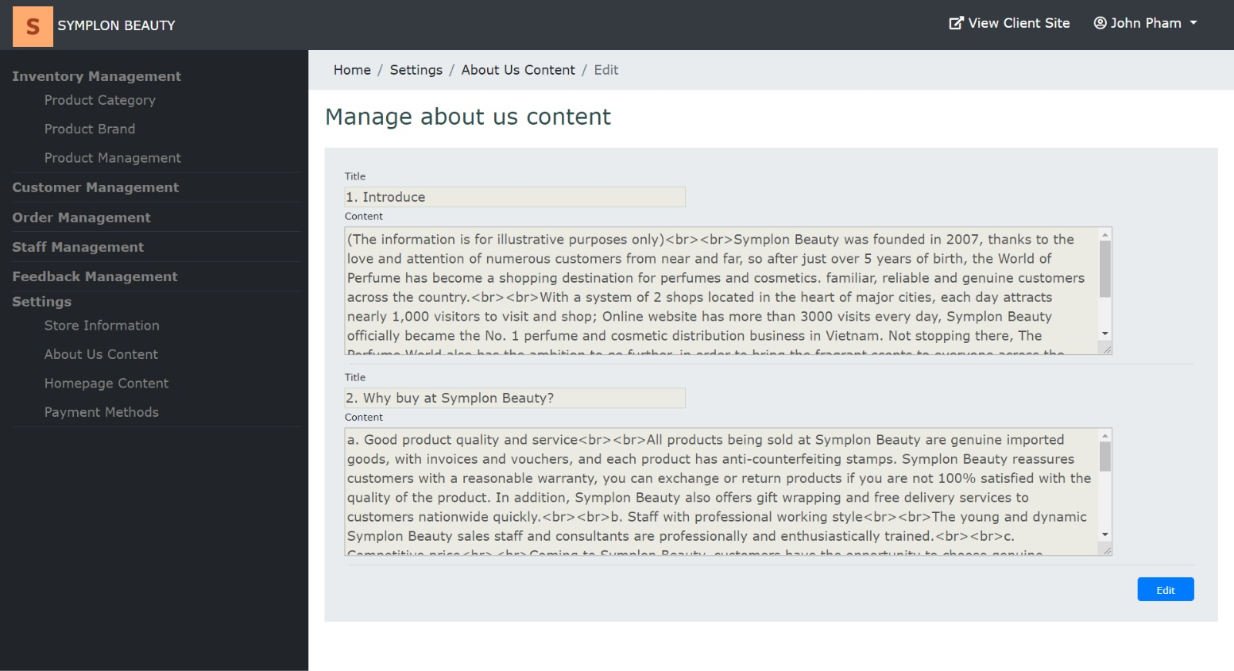

|  |  |
| --- | --- |
| **Operation No.** | **Description** |
| 1 | Click on this option will direct user to the page displaying list of About Us contents |

* **Update About Us contents:** user can update the About Us contents by clicking on “Edit” icon on the list page.

**<**image here**>**

* + To finish updating the About Us contents, user needs to make sure all mandatory fields on the form are filled in:

|  |  |
| --- | --- |
| **Fields** | **Description** |
| Title | * This field is not mandatory. * Allow user to input About Us content’s title * This field will be shown in “About Us” in Customer Site |
| Content | * This field is not mandatory. * Allow user to input About Us content * This field will be shown in “About Us” in Customer Site |

When user submits to update the About Us contents and all the information are correct, About Us contents will be updated in the system.

CHAPTER VII: DEVELOPER GUIDE

* + - 1. ***Install Xampp***
         1. **Change Port:**

1. Open the XAMPP control panel, stop all running modules.
2. Click the “Config” button for the Apache module and select “Apache (httpd.conf)”.
3. Alternately you can open the file located in your XAMPP install folder “/apache/conf/httpd.conf” with a different text editor.
4. Find the following line around line 58 in the file. Port 80 is the default listen port for Apache.

|  |  |
| --- | --- |
|  | Listen 80 |

1. Change it to another port number not in use, for this example we’ll change it to port 8080.

|  |  |
| --- | --- |
|  | Listen 8080 |

1. Find the following line around line 225 in the same file. The ServerName variable is used to give the server a name and port to identify itself with.

|  |  |
| --- | --- |
|  | ServerName localhost:80 |

1. Replace it with the same port number you used in step 4.

|  |  |
| --- | --- |
|  | ServerName localhost:8080 |

1. Save the conf file.

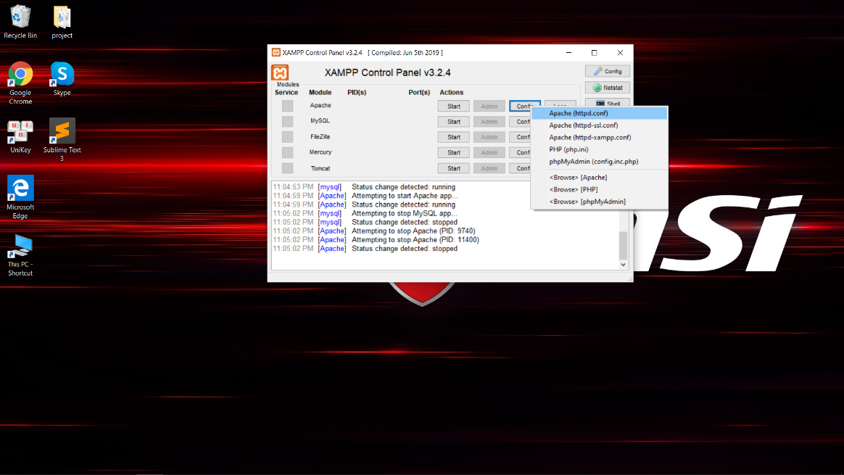

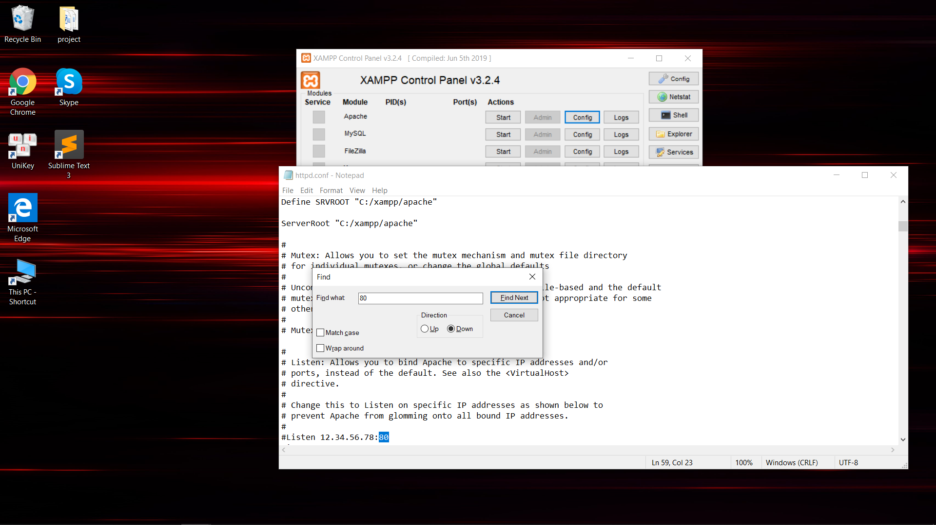

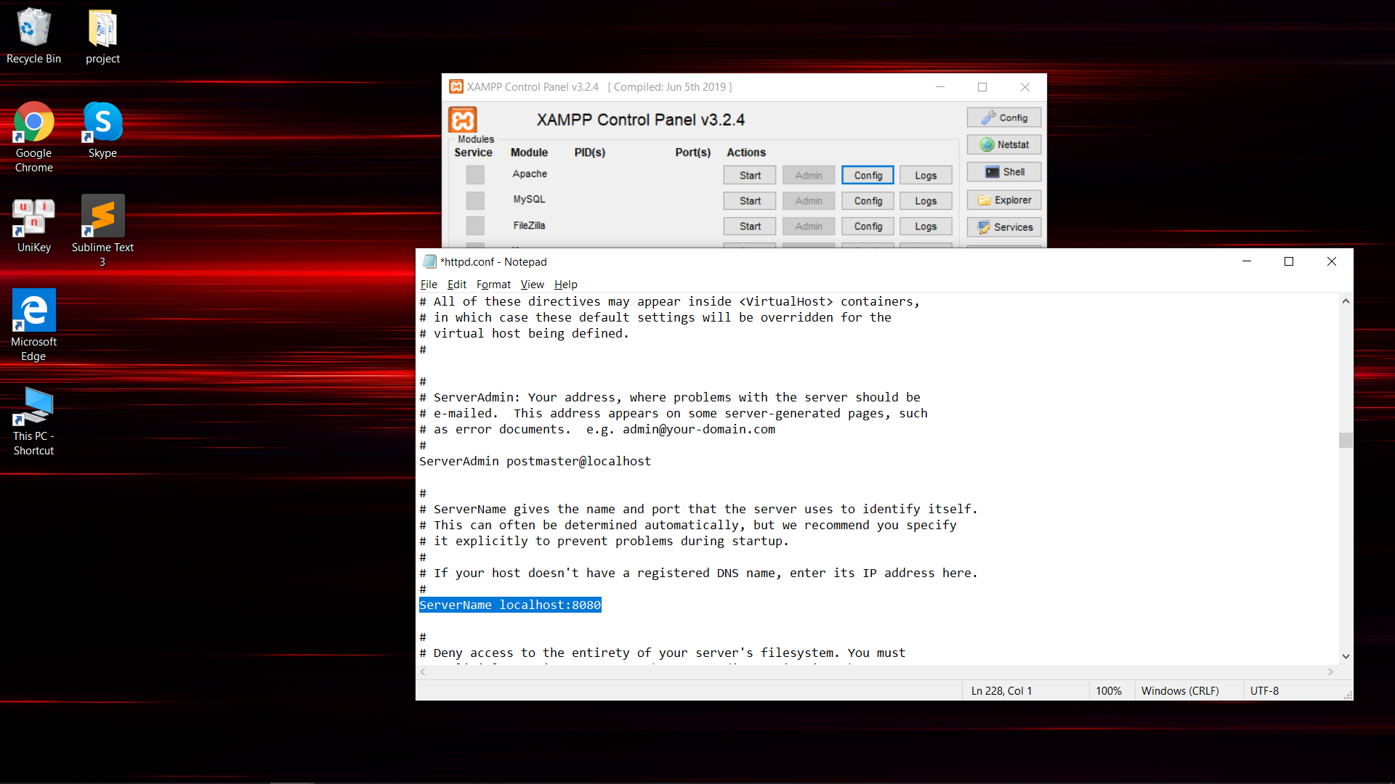

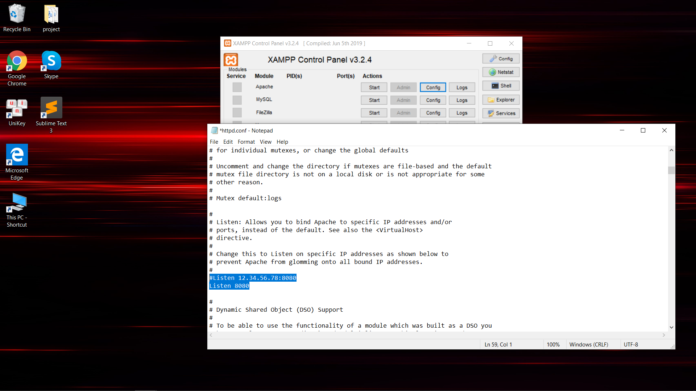

* 1. **Create Account for user xampp:**
  2. Click Start at Apache Module and MySQL Module.

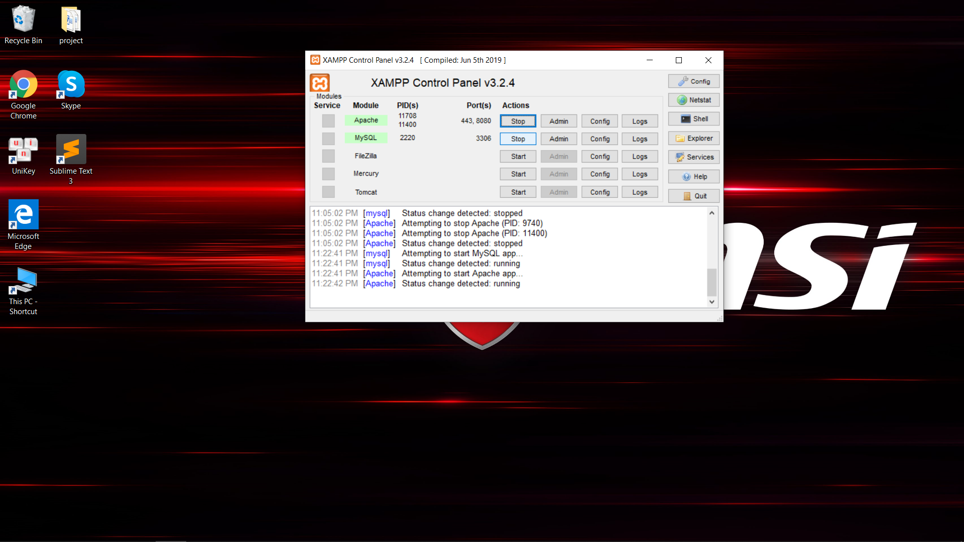

* 1. Open your browser and navigate to “localhost:8080” where you should now see the XAMPP dashboard or click on “Admin” in the XAMPP control panel.
  2. Click phpMyAdmin.

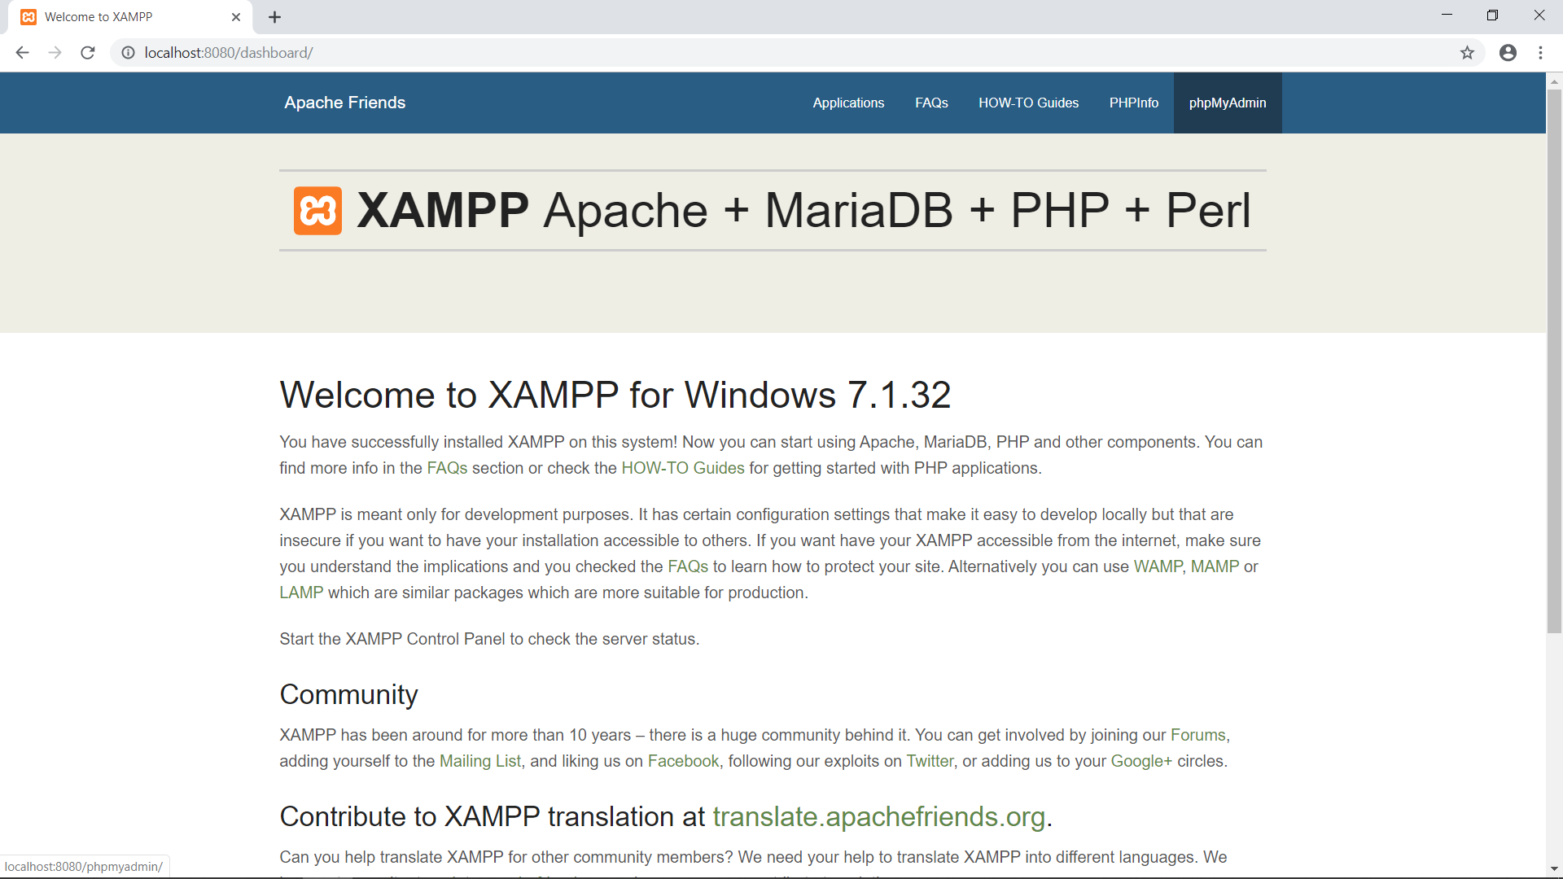

* 1. Click User Accounts -> Click Add User account at top menu.

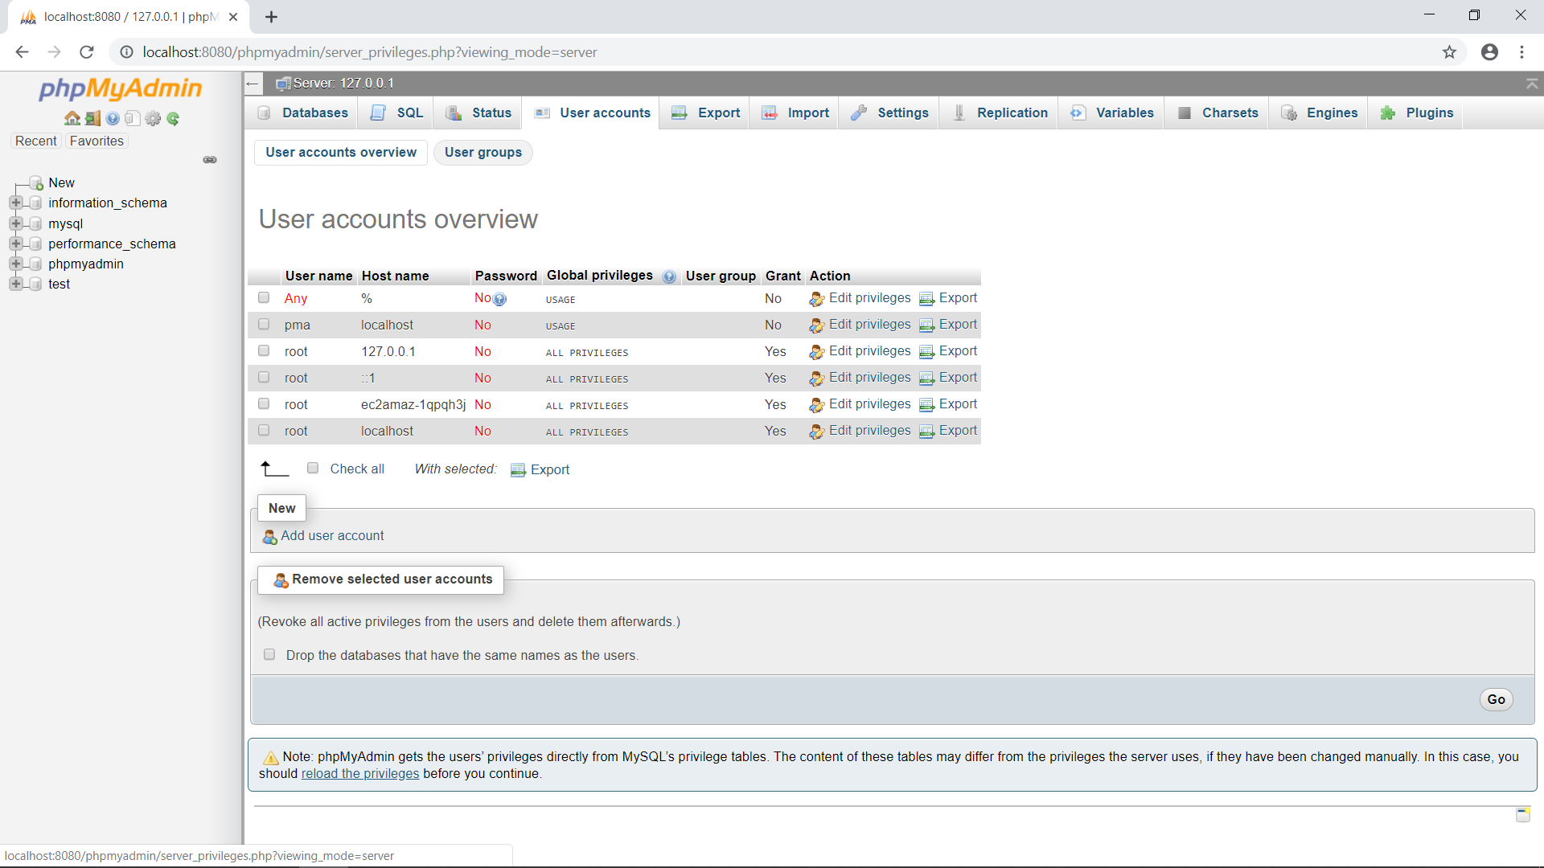

* 1. Fill in user name : groupfour

Host name : Choose Local

Password : administrator

And click Check All

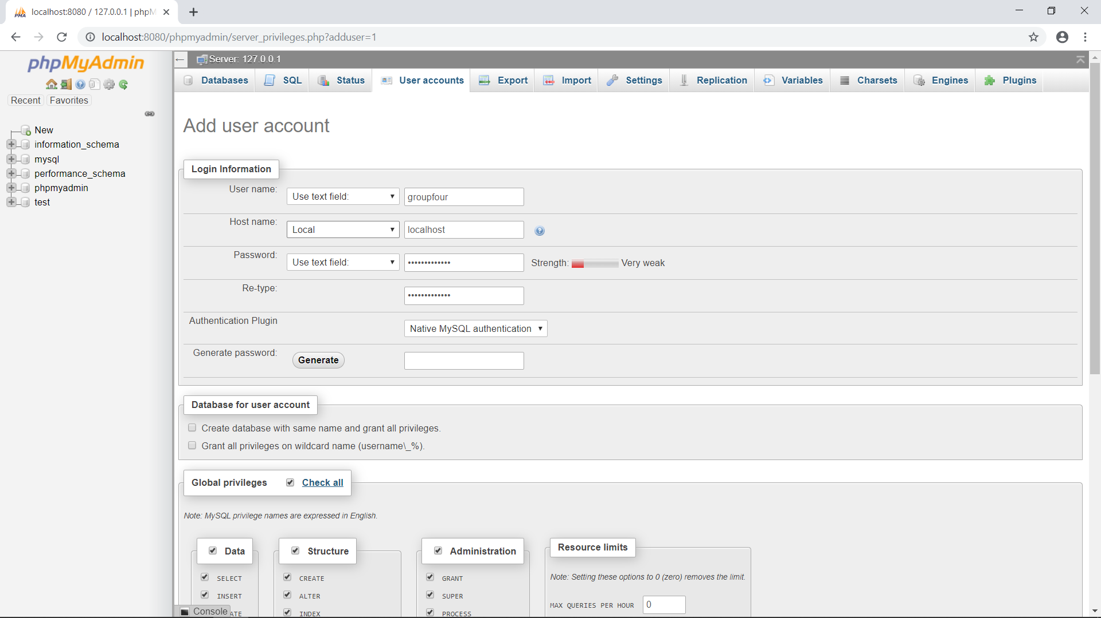

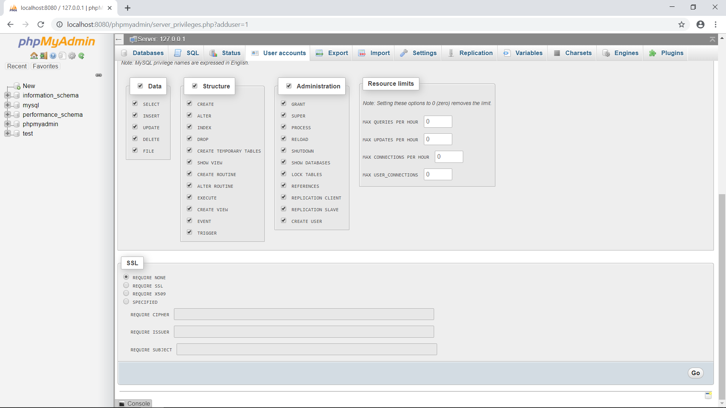

* 1. **Create Database and Data**

1. Click SQL at top menu-> Fill the code in file “E_Commerce_DB.txt ” and click Go.

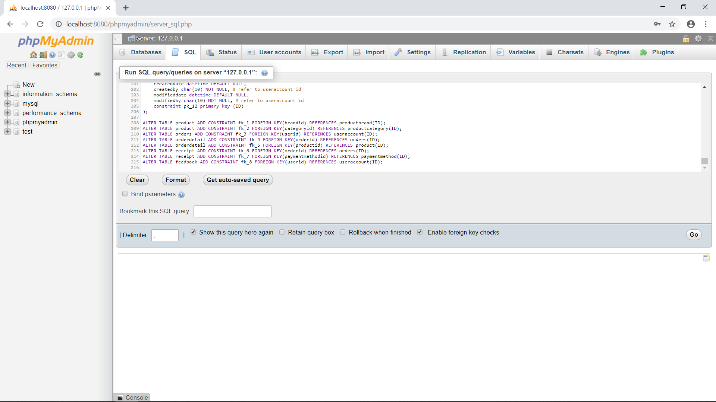

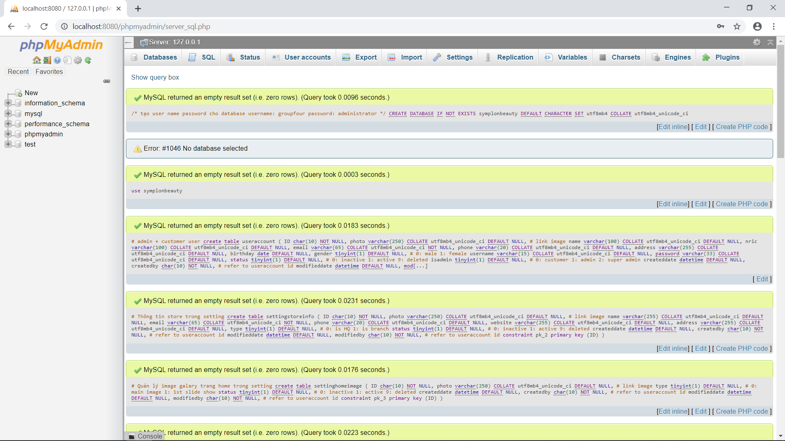

1. Click symblonbeauty-> click SQL at top menu-> fill the code in file “Data_Initial_Script.txt” and click Go.

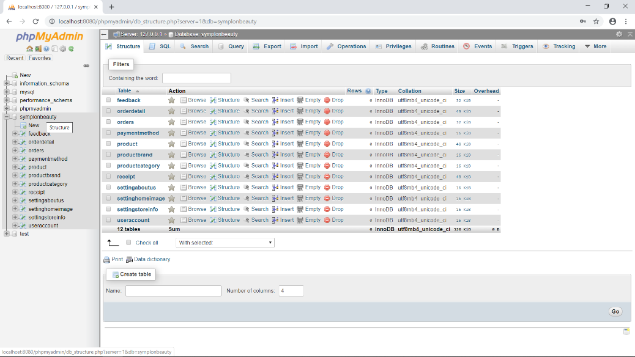

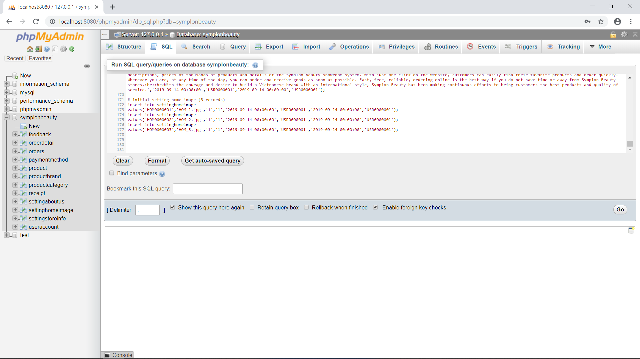

* 1. **Access the website**
     + 1. Copy file Group4_Semester1_FinalProject and paste in file htdocs(Location: C:\xampp\htdocs )
       2. Open your browser and access link below : <http://localhost:8080/Group4_Semester1_FinalProject/Public/CustomerSite/functions/Homepage.php>, And below is the home page of website.

